|  |
| --- |
| CS 524 Introduction to Cloud Computing |
| Dharmit Viradia |
| Lab Assignment 4 |
| Prof. Igor Faynberg |

**Step for Load Balancer Template setup for Amazon Cloud Formation**

* I am using a free template having name Load Balanced Auto Scaling group

<https://s3.amazonaws.com/cloudformation-templates-us-east-1/AutoScalingKeepAtNSample.template>

* Create new Load Balancer Template in JSON as:

{

"AWSTemplateFormatVersion" : "2010-09-09",

"Description" : "AWS CloudFormation Sample Template AutoScalingKeepAtNSample: Create a load balanced, Auto Scaled sample website. This example creates an Auto Scaling group behind a load balancer with a simple health check. **WARNING** This template creates one or more Amazon EC2 instances and an Application Load Balancer. You will be billed for the AWS resources used if you create a stack from this template.",

"Parameters" : {

"VpcId" : {

"Type" : "AWS::EC2::VPC::Id",

"Description" : "VpcId of your existing Virtual Private Cloud (VPC)",

"ConstraintDescription" : "must be the VPC Id of an existing Virtual Private Cloud."

},

"Subnets" : {

"Type" : "List<AWS::EC2::Subnet::Id>",

"Description" : "The list of SubnetIds in your Virtual Private Cloud (VPC)",

"ConstraintDescription" : "must be a list of at least two existing subnets associated with at least two different availability zones. They should be residing in the selected Virtual Private Cloud."

},

"InstanceType" : {

"Description" : "WebServer EC2 instance type",

"Type" : "String",

"Default" : "t2.micro",

"AllowedValues" : [ "t1.micro", "t2.nano", "t2.micro", "t2.small", "t2.medium", "t2.large", "m1.small", "m1.medium", "m1.large", "m1.xlarge", "m2.xlarge", "m2.2xlarge", "m2.4xlarge", "m3.medium", "m3.large", "m3.xlarge", "m3.2xlarge", "m4.large", "m4.xlarge", "m4.2xlarge", "m4.4xlarge", "m4.10xlarge", "c1.medium", "c1.xlarge", "c3.large", "c3.xlarge", "c3.2xlarge", "c3.4xlarge", "c3.8xlarge", "c4.large", "c4.xlarge", "c4.2xlarge", "c4.4xlarge", "c4.8xlarge", "g2.2xlarge", "g2.8xlarge", "r3.large", "r3.xlarge", "r3.2xlarge", "r3.4xlarge", "r3.8xlarge", "i2.xlarge", "i2.2xlarge", "i2.4xlarge", "i2.8xlarge", "d2.xlarge", "d2.2xlarge", "d2.4xlarge", "d2.8xlarge", "hi1.4xlarge", "hs1.8xlarge", "cr1.8xlarge", "cc2.8xlarge", "cg1.4xlarge"],

"ConstraintDescription" : "must be a valid EC2 instance type."

},

"KeyName" : {

"Description" : "Name of an existing EC2 KeyPair to enable SSH access to the instances",

"Type" : "AWS::EC2::KeyPair::KeyName",

"Default": "ec2@dharmit",

"MinLength": "1",

"MaxLength": "255",

"AllowedPattern" : "[\\x20-\\x7E]*",

"ConstraintDescription" : "can contain only ASCII characters."

},

"Location" : {

"Description" : "The IP address range that can be used to SSH to the EC2 instances",

"Type": "String",

"MinLength": "9",

"MaxLength": "18",

"Default": "71.255.89.254/32",

"AllowedPattern": "(\\d{1,3})\\.(\\d{1,3})\\.(\\d{1,3})\\.(\\d{1,3})/(\\d{1,2})",

"ConstraintDescription": "must be a valid IP CIDR range of the form x.x.x.x/x."

}

},

"Mappings" : {

"Region2Examples" : {

"us-east-1" : { "Examples" : "https://s3.amazonaws.com/cloudformation-examples-us-east-1" },

"us-west-2" : { "Examples" : "https://s3-us-west-2.amazonaws.com/cloudformation-examples-us-west-2" },

"us-west-1" : { "Examples" : "https://s3-us-west-1.amazonaws.com/cloudformation-examples-us-west-1" },

"eu-west-1" : { "Examples" : "https://s3-eu-west-1.amazonaws.com/cloudformation-examples-eu-west-1" },

"eu-west-2" : { "Examples" : "https://s3-eu-west-2.amazonaws.com/cloudformation-examples-eu-west-2" },

"eu-west-3" : { "Examples" : "https://s3-eu-west-3.amazonaws.com/cloudformation-examples-eu-west-3" },

"eu-north-1" : { "Examples" : "https://s3-eu-north-1.amazonaws.com/cloudformation-examples-eu-north-1" },

"eu-central-1" : { "Examples" : "https://s3-eu-central-1.amazonaws.com/cloudformation-examples-eu-central-1" },

"ap-southeast-1" : { "Examples" : "https://s3-ap-southeast-1.amazonaws.com/cloudformation-examples-ap-southeast-1" },

"ap-northeast-1" : { "Examples" : "https://s3-ap-northeast-1.amazonaws.com/cloudformation-examples-ap-northeast-1" },

"ap-northeast-2" : { "Examples" : "https://s3-ap-northeast-2.amazonaws.com/cloudformation-examples-ap-northeast-2" },

"ap-northeast-3" : { "Examples" : "https://s3-ap-northeast-3.amazonaws.com/cloudformation-examples-ap-northeast-3" },

"ap-southeast-2" : { "Examples" : "https://s3-ap-southeast-2.amazonaws.com/cloudformation-examples-ap-southeast-2" },

"ap-south-1" : { "Examples" : "https://s3-ap-south-1.amazonaws.com/cloudformation-examples-ap-south-1" },

"us-east-2" : { "Examples" : "https://s3-us-east-2.amazonaws.com/cloudformation-examples-us-east-2" },

"ca-central-1" : { "Examples" : "https://s3-ca-central-1.amazonaws.com/cloudformation-examples-ca-central-1" },

"sa-east-1" : { "Examples" : "https://s3-sa-east-1.amazonaws.com/cloudformation-examples-sa-east-1" },

"cn-north-1" : { "Examples" : "https://s3.cn-north-1.amazonaws.com.cn/cloudformation-examples-cn-north-1" },

"cn-northwest-1" : { "Examples" : "https://s3.cn-northwest-1.amazonaws.com.cn/cloudformation-examples-cn-northwest-1" }

}

,

"AWSInstanceType2Arch" : {

"t1.micro" : { "Arch" : "HVM64" },

"t2.nano" : { "Arch" : "HVM64" },

"t2.micro" : { "Arch" : "HVM64" },

"t2.small" : { "Arch" : "HVM64" },

"t2.medium" : { "Arch" : "HVM64" },

"t2.large" : { "Arch" : "HVM64" },

"m1.small" : { "Arch" : "HVM64" },

"m1.medium" : { "Arch" : "HVM64" },

"m1.large" : { "Arch" : "HVM64" },

"m1.xlarge" : { "Arch" : "HVM64" },

"m2.xlarge" : { "Arch" : "HVM64" },

"m2.2xlarge" : { "Arch" : "HVM64" },

"m2.4xlarge" : { "Arch" : "HVM64" },

"m3.medium" : { "Arch" : "HVM64" },

"m3.large" : { "Arch" : "HVM64" },

"m3.xlarge" : { "Arch" : "HVM64" },

"m3.2xlarge" : { "Arch" : "HVM64" },

"m4.large" : { "Arch" : "HVM64" },

"m4.xlarge" : { "Arch" : "HVM64" },

"m4.2xlarge" : { "Arch" : "HVM64" },

"m4.4xlarge" : { "Arch" : "HVM64" },

"m4.10xlarge" : { "Arch" : "HVM64" },

"c1.medium" : { "Arch" : "HVM64" },

"c1.xlarge" : { "Arch" : "HVM64" },

"c3.large" : { "Arch" : "HVM64" },

"c3.xlarge" : { "Arch" : "HVM64" },

"c3.2xlarge" : { "Arch" : "HVM64" },

"c3.4xlarge" : { "Arch" : "HVM64" },

"c3.8xlarge" : { "Arch" : "HVM64" },

"c4.large" : { "Arch" : "HVM64" },

"c4.xlarge" : { "Arch" : "HVM64" },

"c4.2xlarge" : { "Arch" : "HVM64" },

"c4.4xlarge" : { "Arch" : "HVM64" },

"c4.8xlarge" : { "Arch" : "HVM64" },

"g2.2xlarge" : { "Arch" : "HVMG2" },

"g2.8xlarge" : { "Arch" : "HVMG2" },

"r3.large" : { "Arch" : "HVM64" },

"r3.xlarge" : { "Arch" : "HVM64" },

"r3.2xlarge" : { "Arch" : "HVM64" },

"r3.4xlarge" : { "Arch" : "HVM64" },

"r3.8xlarge" : { "Arch" : "HVM64" },

"i2.xlarge" : { "Arch" : "HVM64" },

"i2.2xlarge" : { "Arch" : "HVM64" },

"i2.4xlarge" : { "Arch" : "HVM64" },

"i2.8xlarge" : { "Arch" : "HVM64" },

"d2.xlarge" : { "Arch" : "HVM64" },

"d2.2xlarge" : { "Arch" : "HVM64" },

"d2.4xlarge" : { "Arch" : "HVM64" },

"d2.8xlarge" : { "Arch" : "HVM64" },

"hi1.4xlarge" : { "Arch" : "HVM64" },

"hs1.8xlarge" : { "Arch" : "HVM64" },

"cr1.8xlarge" : { "Arch" : "HVM64" },

"cc2.8xlarge" : { "Arch" : "HVM64" }

},

"AWSInstanceType2NATArch" : {

"t1.micro" : { "Arch" : "NATHVM64" },

"t2.nano" : { "Arch" : "NATHVM64" },

"t2.micro" : { "Arch" : "NATHVM64" },

"t2.small" : { "Arch" : "NATHVM64" },

"t2.medium" : { "Arch" : "NATHVM64" },

"t2.large" : { "Arch" : "NATHVM64" },

"m1.small" : { "Arch" : "NATHVM64" },

"m1.medium" : { "Arch" : "NATHVM64" },

"m1.large" : { "Arch" : "NATHVM64" },

"m1.xlarge" : { "Arch" : "NATHVM64" },

"m2.xlarge" : { "Arch" : "NATHVM64" },

"m2.2xlarge" : { "Arch" : "NATHVM64" },

"m2.4xlarge" : { "Arch" : "NATHVM64" },

"m3.medium" : { "Arch" : "NATHVM64" },

"m3.large" : { "Arch" : "NATHVM64" },

"m3.xlarge" : { "Arch" : "NATHVM64" },

"m3.2xlarge" : { "Arch" : "NATHVM64" },

"m4.large" : { "Arch" : "NATHVM64" },

"m4.xlarge" : { "Arch" : "NATHVM64" },

"m4.2xlarge" : { "Arch" : "NATHVM64" },

"m4.4xlarge" : { "Arch" : "NATHVM64" },

"m4.10xlarge" : { "Arch" : "NATHVM64" },

"c1.medium" : { "Arch" : "NATHVM64" },

"c1.xlarge" : { "Arch" : "NATHVM64" },

"c3.large" : { "Arch" : "NATHVM64" },

"c3.xlarge" : { "Arch" : "NATHVM64" },

"c3.2xlarge" : { "Arch" : "NATHVM64" },

"c3.4xlarge" : { "Arch" : "NATHVM64" },

"c3.8xlarge" : { "Arch" : "NATHVM64" },

"c4.large" : { "Arch" : "NATHVM64" },

"c4.xlarge" : { "Arch" : "NATHVM64" },

"c4.2xlarge" : { "Arch" : "NATHVM64" },

"c4.4xlarge" : { "Arch" : "NATHVM64" },

"c4.8xlarge" : { "Arch" : "NATHVM64" },

"g2.2xlarge" : { "Arch" : "NATHVMG2" },

"g2.8xlarge" : { "Arch" : "NATHVMG2" },

"r3.large" : { "Arch" : "NATHVM64" },

"r3.xlarge" : { "Arch" : "NATHVM64" },

"r3.2xlarge" : { "Arch" : "NATHVM64" },

"r3.4xlarge" : { "Arch" : "NATHVM64" },

"r3.8xlarge" : { "Arch" : "NATHVM64" },

"i2.xlarge" : { "Arch" : "NATHVM64" },

"i2.2xlarge" : { "Arch" : "NATHVM64" },

"i2.4xlarge" : { "Arch" : "NATHVM64" },

"i2.8xlarge" : { "Arch" : "NATHVM64" },

"d2.xlarge" : { "Arch" : "NATHVM64" },

"d2.2xlarge" : { "Arch" : "NATHVM64" },

"d2.4xlarge" : { "Arch" : "NATHVM64" },

"d2.8xlarge" : { "Arch" : "NATHVM64" },

"hi1.4xlarge" : { "Arch" : "NATHVM64" },

"hs1.8xlarge" : { "Arch" : "NATHVM64" },

"cr1.8xlarge" : { "Arch" : "NATHVM64" },

"cc2.8xlarge" : { "Arch" : "NATHVM64" }

}

,

"AWSRegionArch2AMI" : {

"us-east-1" : {"HVM64" : "ami-0080e4c5bc078760e", "HVMG2" : "ami-0aeb704d503081ea6"},

"us-west-2" : {"HVM64" : "ami-01e24be29428c15b2", "HVMG2" : "ami-0fe84a5b4563d8f27"},

"us-west-1" : {"HVM64" : "ami-0ec6517f6edbf8044", "HVMG2" : "ami-0a7fc72dc0e51aa77"},

"eu-west-1" : {"HVM64" : "ami-08935252a36e25f85", "HVMG2" : "ami-0d5299b1c6112c3c7"},

"eu-west-2" : {"HVM64" : "ami-01419b804382064e4", "HVMG2" : "NOT_SUPPORTED"},

"eu-west-3" : {"HVM64" : "ami-0dd7e7ed60da8fb83", "HVMG2" : "NOT_SUPPORTED"},

"eu-central-1" : {"HVM64" : "ami-0cfbf4f6db41068ac", "HVMG2" : "ami-0aa1822e3eb913a11"},

"eu-north-1" : {"HVM64" : "ami-86fe70f8", "HVMG2" : "ami-32d55b4c"},

"ap-northeast-1" : {"HVM64" : "ami-00a5245b4816c38e6", "HVMG2" : "ami-09d0e0e099ecabba2"},

"ap-northeast-2" : {"HVM64" : "ami-00dc207f8ba6dc919", "HVMG2" : "NOT_SUPPORTED"},

"ap-northeast-3" : {"HVM64" : "ami-0b65f69a5c11f3522", "HVMG2" : "NOT_SUPPORTED"},

"ap-southeast-1" : {"HVM64" : "ami-05b3bcf7f311194b3", "HVMG2" : "ami-0e46ce0d6a87dc979"},

"ap-southeast-2" : {"HVM64" : "ami-02fd0b06f06d93dfc", "HVMG2" : "ami-0c0ab057a101d8ff2"},

"ap-south-1" : {"HVM64" : "ami-0ad42f4f66f6c1cc9", "HVMG2" : "ami-0244c1d42815af84a"},

"us-east-2" : {"HVM64" : "ami-0cd3dfa4e37921605", "HVMG2" : "NOT_SUPPORTED"},

"ca-central-1" : {"HVM64" : "ami-07423fb63ea0a0930", "HVMG2" : "NOT_SUPPORTED"},

"sa-east-1" : {"HVM64" : "ami-05145e0b28ad8e0b2", "HVMG2" : "NOT_SUPPORTED"},

"cn-north-1" : {"HVM64" : "ami-053617c9d818c1189", "HVMG2" : "NOT_SUPPORTED"},

"cn-northwest-1" : {"HVM64" : "ami-0f7937761741dc640", "HVMG2" : "NOT_SUPPORTED"}

}

},

"Resources" : {

"WebServerGroup" : {

"Type" : "AWS::AutoScaling::AutoScalingGroup",

"Properties" : {

"VPCZoneIdentifier" : { "Ref" : "Subnets" },

"LaunchConfigurationName" : { "Ref" : "LaunchConfig" },

"MinSize" : "2",

"MaxSize" : "2",

"TargetGroupARNs" : [ { "Ref" : "ALBTargetGroup" } ]

},

"CreationPolicy" : {

"ResourceSignal" : {

"Timeout" : "PT15M",

"Count" : "2"

}

},

"UpdatePolicy": {

"AutoScalingRollingUpdate": {

"MinInstancesInService": "1",

"MaxBatchSize": "1",

"PauseTime" : "PT15M",

"WaitOnResourceSignals": "true"

}

}

},

"LaunchConfig" : {

"Type" : "AWS::AutoScaling::LaunchConfiguration",

"Metadata" : {

"Comment" : "Install a simple application",

"AWS::CloudFormation::Init" : {

"config" : {

"packages" : {

"yum" : {

"httpd" : []

}

},

"files" : {

"/var/www/html/index.html" : {

"content" : { "Fn::Join" : ["\n", [

"<img src=\"", {"Fn::FindInMap" : ["Region2Examples", {"Ref" : "AWS::Region"}, "Examples"]}, "/cloudformation_graphic.png\" alt=\"AWS CloudFormation Logo\"/>",

"<h1>Congratulations, you have successfully launched the AWS CloudFormation sample.</h1>"

]]},

"mode" : "000644",

"owner" : "root",

"group" : "root"

},

"/etc/cfn/cfn-hup.conf" : {

"content" : { "Fn::Join" : ["", [

"[main]\n",

"stack=", { "Ref" : "AWS::StackId" }, "\n",

"region=", { "Ref" : "AWS::Region" }, "\n"

]]},

"mode" : "000400",

"owner" : "root",

"group" : "root"

},

"/etc/cfn/hooks.d/cfn-auto-reloader.conf" : {

"content": { "Fn::Join" : ["", [

"[cfn-auto-reloader-hook]\n",

"triggers=post.update\n",

"path=Resources.LaunchConfig.Metadata.AWS::CloudFormation::Init\n",

"action=/opt/aws/bin/cfn-init -v ",

" --stack ", { "Ref" : "AWS::StackName" },

" --resource LaunchConfig ",

" --region ", { "Ref" : "AWS::Region" }, "\n",

"runas=root\n"

]]},

"mode" : "000400",

"owner" : "root",

"group" : "root"

}

},

"services" : {

"sysvinit" : {

"httpd" : { "enabled" : "true", "ensureRunning" : "true" },

"cfn-hup" : { "enabled" : "true", "ensureRunning" : "true",

"files" : ["/etc/cfn/cfn-hup.conf", "/etc/cfn/hooks.d/cfn-auto-reloader.conf"]}

}

}

}

}

},

"Properties" : {

"KeyName" : { "Ref" : "KeyName" },

"ImageId" : { "Fn::FindInMap" : [ "AWSRegionArch2AMI", { "Ref" : "AWS::Region" },

{ "Fn::FindInMap" : [ "AWSInstanceType2Arch", { "Ref" : "InstanceType" }, "Arch" ] } ] },

"SecurityGroups" : [ { "Ref" : "InstanceSecurityGroup" } ],

"InstanceType" : { "Ref" : "InstanceType" },

"UserData" : { "Fn::Base64" : { "Fn::Join" : ["", [

"#!/bin/bash -xe\n",

"yum update -y aws-cfn-bootstrap\n",

"/opt/aws/bin/cfn-init -v ",

" --stack ", { "Ref" : "AWS::StackName" },

" --resource LaunchConfig ",

" --region ", { "Ref" : "AWS::Region" }, "\n",

"/opt/aws/bin/cfn-signal -e $? ",

" --stack ", { "Ref" : "AWS::StackName" },

" --resource WebServerGroup ",

" --region ", { "Ref" : "AWS::Region" }, "\n"

]]}}

}

},

"ApplicationLoadBalancer" : {

"Type" : "AWS::ElasticLoadBalancingV2::LoadBalancer",

"Properties" : {

"Subnets" : { "Ref" : "Subnets"}

}

},

"ALBListener" : {

"Type" : "AWS::ElasticLoadBalancingV2::Listener",

"Properties" : {

"DefaultActions" : [{

"Type" : "forward",

"TargetGroupArn" : { "Ref" : "ALBTargetGroup" }

}],

"LoadBalancerArn" : { "Ref" : "ApplicationLoadBalancer" },

"Port" : "80",

"Protocol" : "HTTP"

}

},

"ALBTargetGroup" : {

"Type" : "AWS::ElasticLoadBalancingV2::TargetGroup",

"Properties" : {

"HealthCheckIntervalSeconds" : 30,

"HealthCheckTimeoutSeconds" : 5,

"HealthyThresholdCount" : 3,

"Port" : 80,

"Protocol" : "HTTP",

"UnhealthyThresholdCount" : 5,

"VpcId" : {"Ref" : "VpcId"}

}

},

"InstanceSecurityGroup" : {

"Type" : "AWS::EC2::SecurityGroup",

"Properties" : {

"GroupDescription" : "Enable SSH access and HTTP access on the configured port",

"GroupName" : "Load Balancer SecurityGroup",

"SecurityGroupIngress" :

[ { "IpProtocol" : "tcp", "FromPort" : "22", "ToPort" : "22", "CidrIp" : { "Ref" : "Location"} },

{ "IpProtocol" : "tcp", "FromPort" : "80", "ToPort" : "80", "CidrIp" : “0.0.0.0/0” } ],

"VpcId" : { "Ref" : "VpcId" }

}

}

},

"Outputs" : {

"URL" : {

"Description" : "URL of the website",

"Value" : { "Fn::Join" : [ "", [ "http://", { "Fn::GetAtt" : [

"ApplicationLoadBalancer", "DNSName" ]}]]}

}

}

}

**Step for Creating a CloudFormation**

* First login into your AWS account

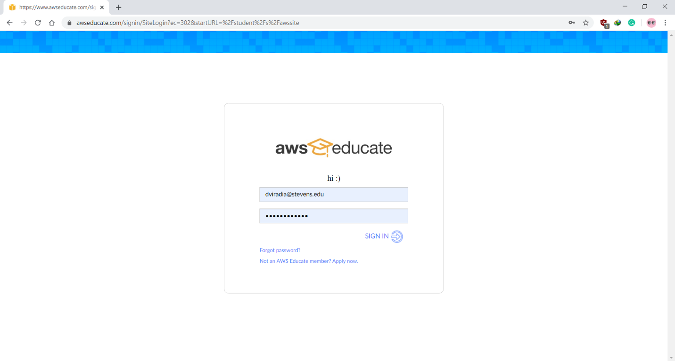

* Upload Template to S3 Bucket and give Public Access

I have used already created bucket from previous Lab

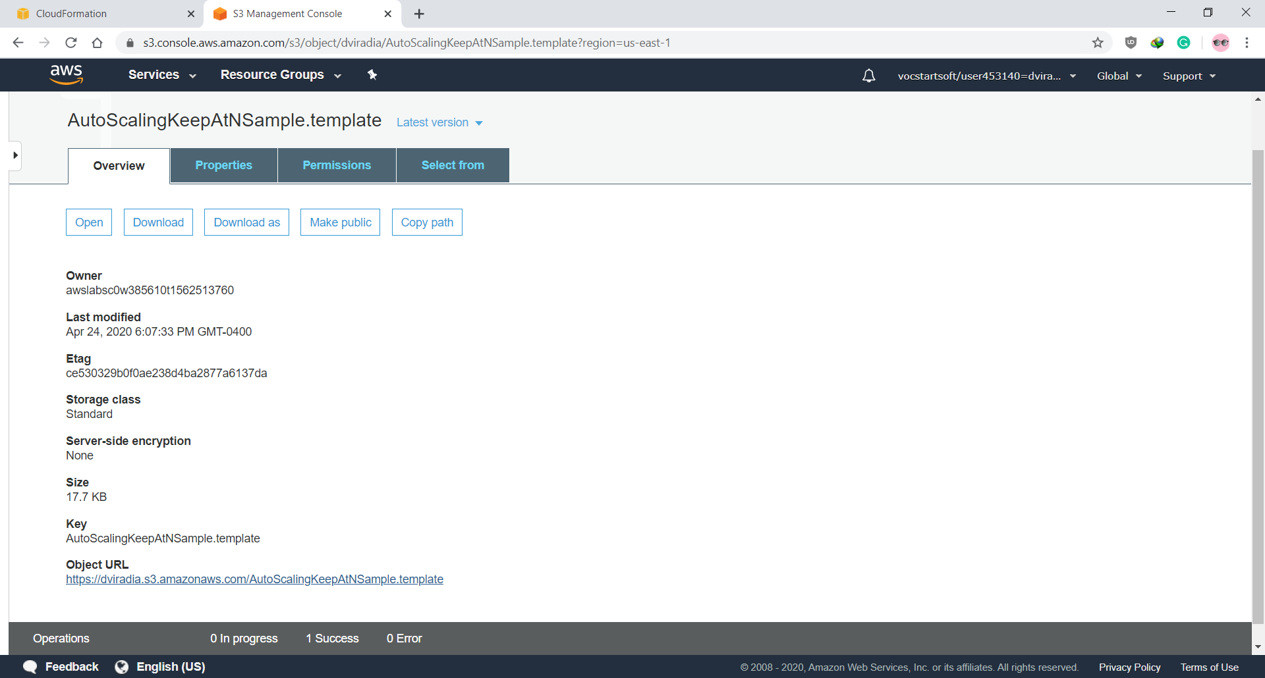

* On AWS Dashboard go to CloudFormation Services and Click on Create Stack button

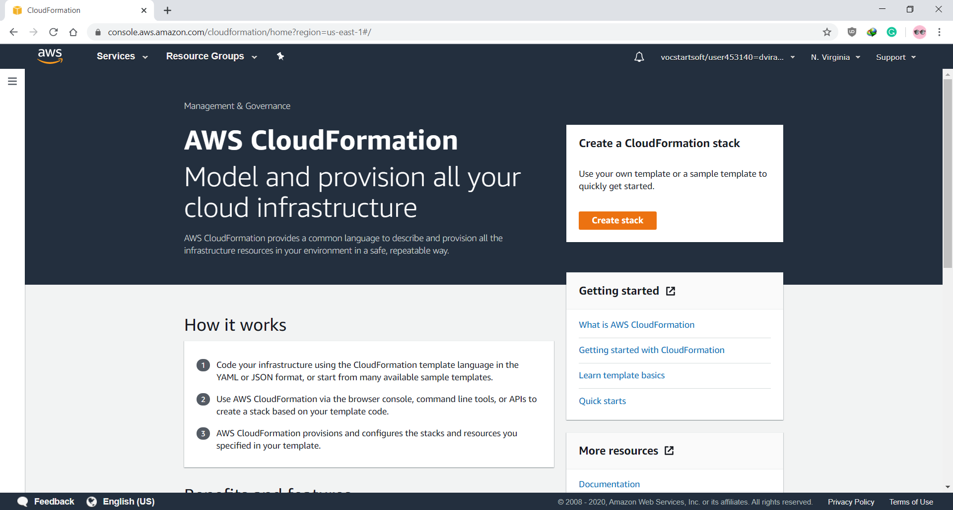

* Now, selecting a recently created template from the S3 directory and click on next

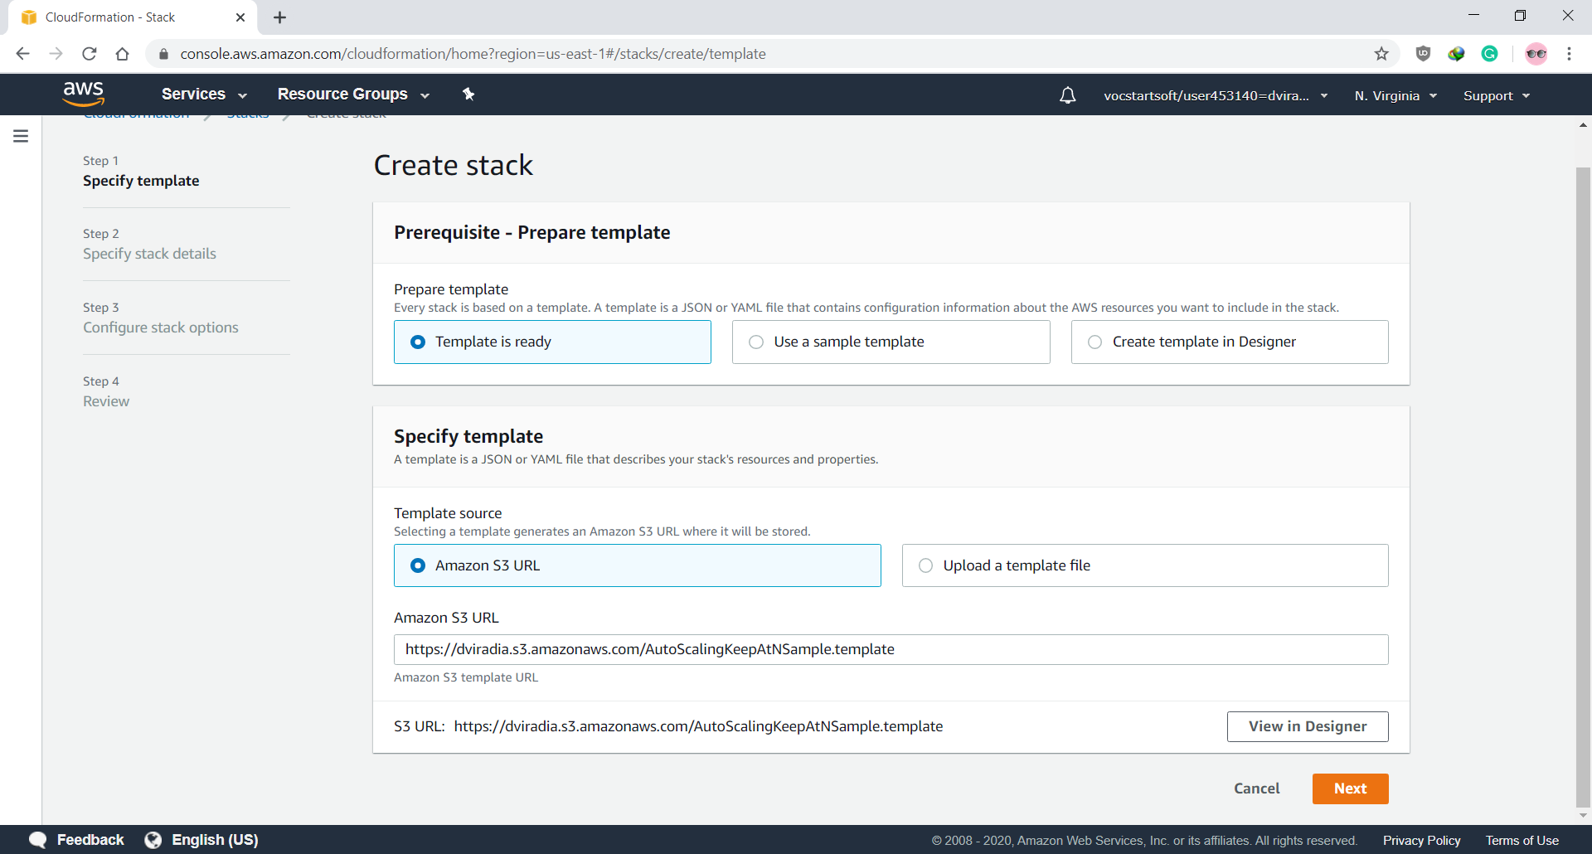

* In this step, we have to specify parameters after selecting template. Click next to proceed.

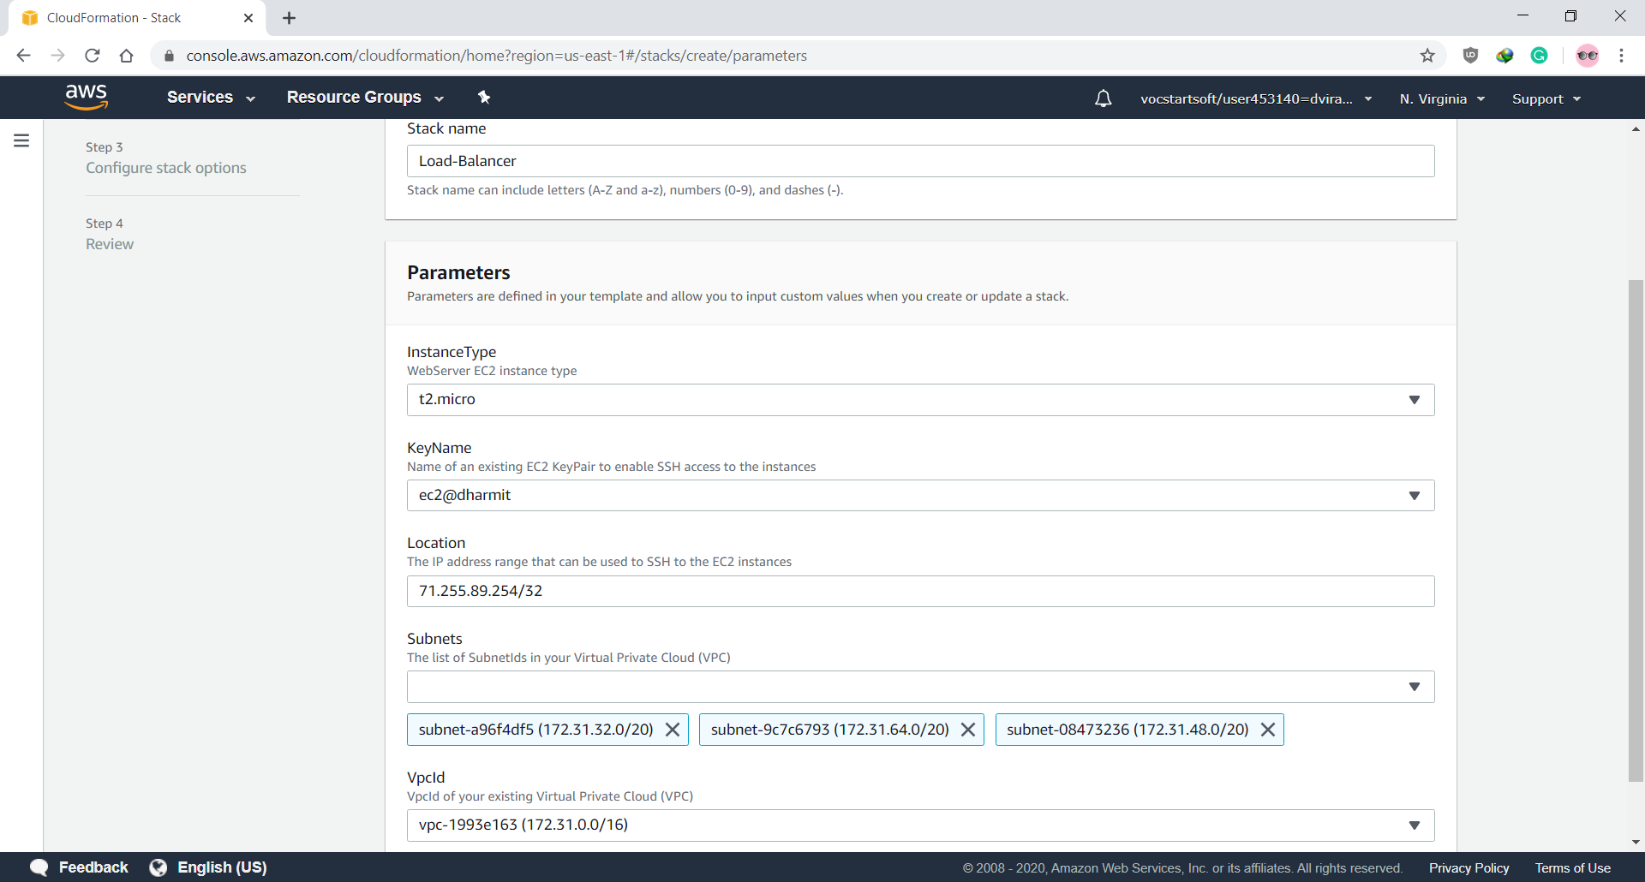

* After not making any changes in Option menu, we came to Review menu to review the details of created stack. And finally clicking to Create button to create a stack

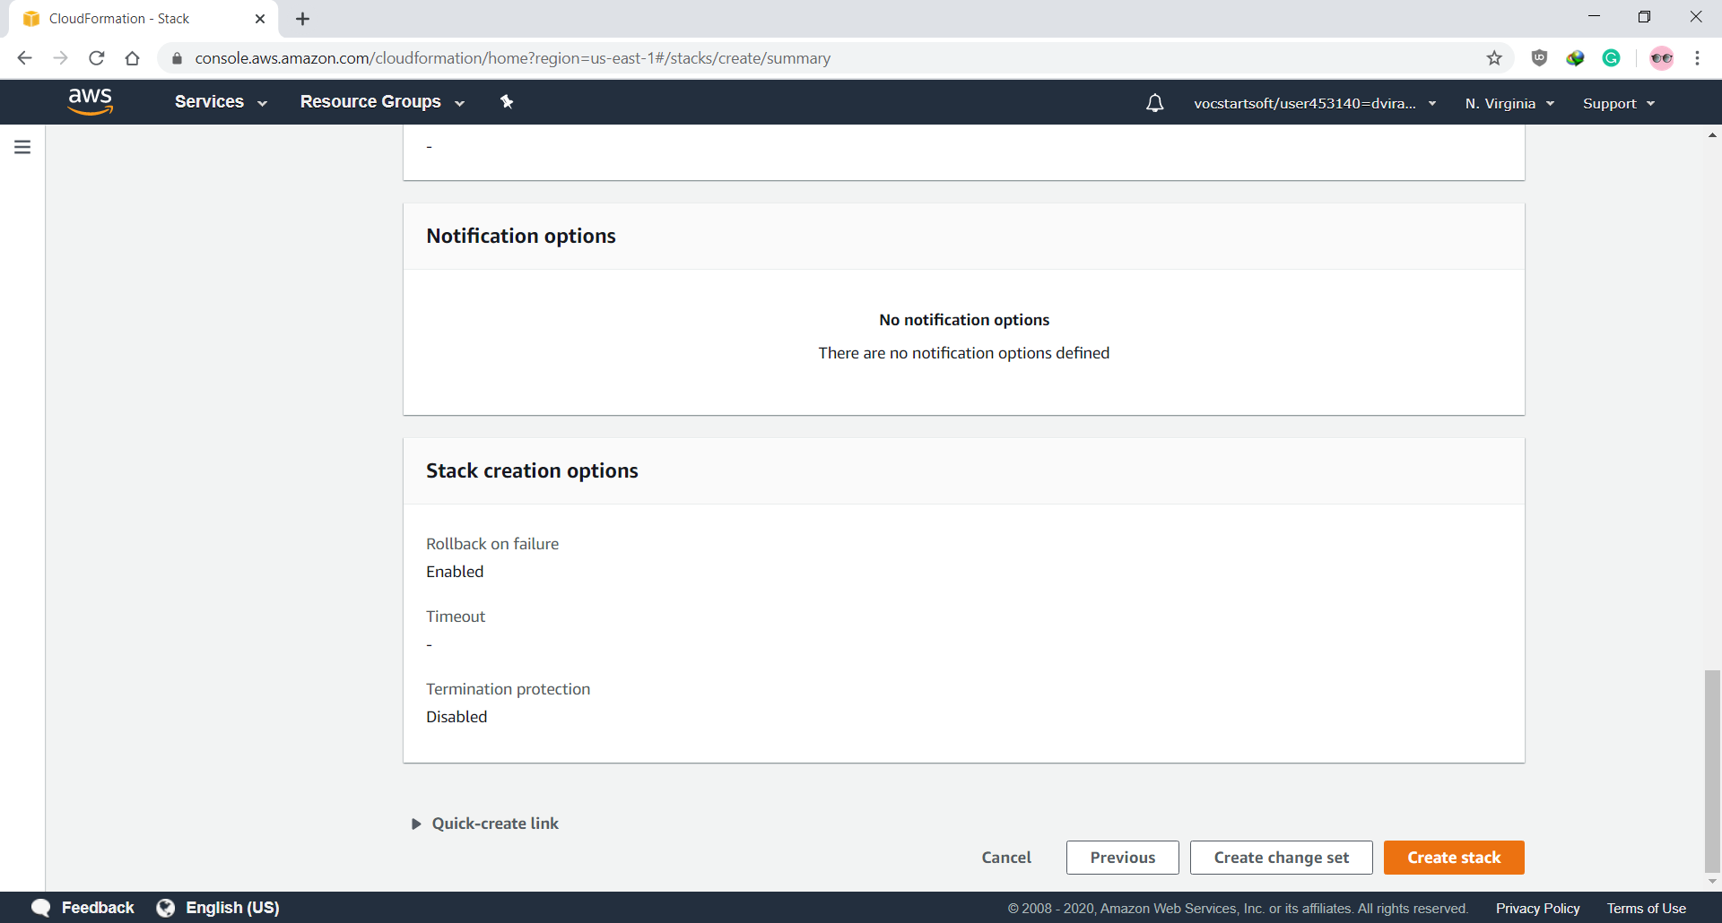

* After the creation of stack successfully, the status changes to “CREATE_COMPLETE”. And we can check the Load Balancer URL in the output tab.

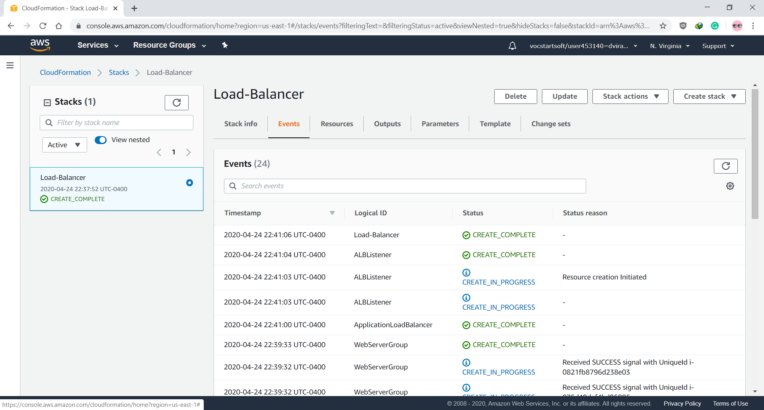

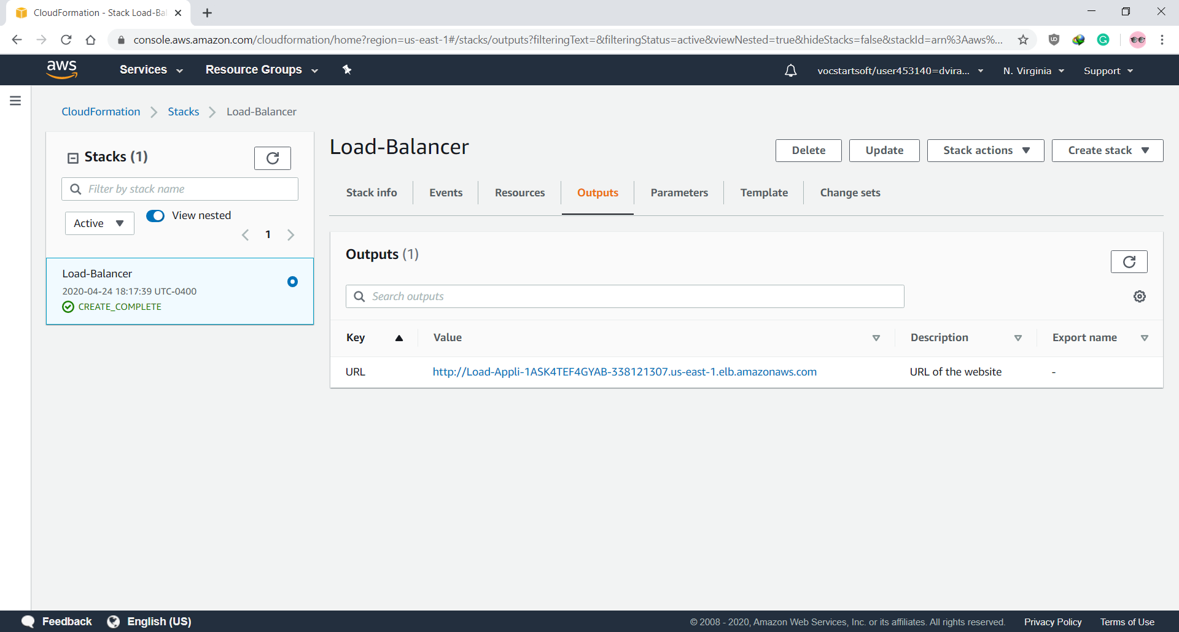

**Step for Updating a Stack by Amazon Cloud Formation**

* Now, after successful execution of servers on instances. I will change the minSize and maxSize value to 4 from 2 in Auto Scaling

"Resources" : {

"WebServerGroup" : {

"Type" : "AWS::AutoScaling::AutoScalingGroup",

"Properties" : {

"VPCZoneIdentifier" : { "Ref" : "Subnets" },

"LaunchConfigurationName" : { "Ref" : "LaunchConfig" },

"MinSize" : "4",

"MaxSize" : "4",

"TargetGroupARNs" : [ { "Ref" : "ALBTargetGroup" } ]

},

* Now Upload the Updated Template to S3 Bucket

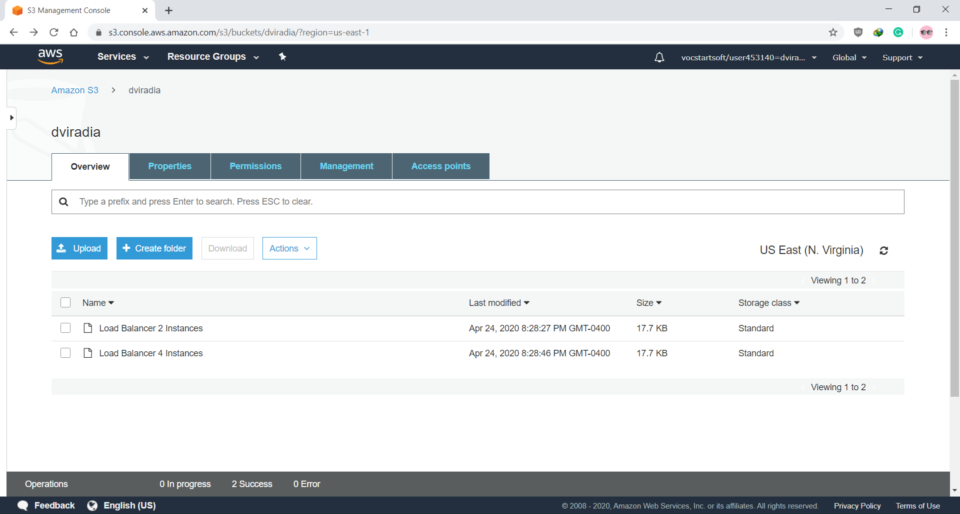

* Now on CloudFormation Dashboard Click on Update tab

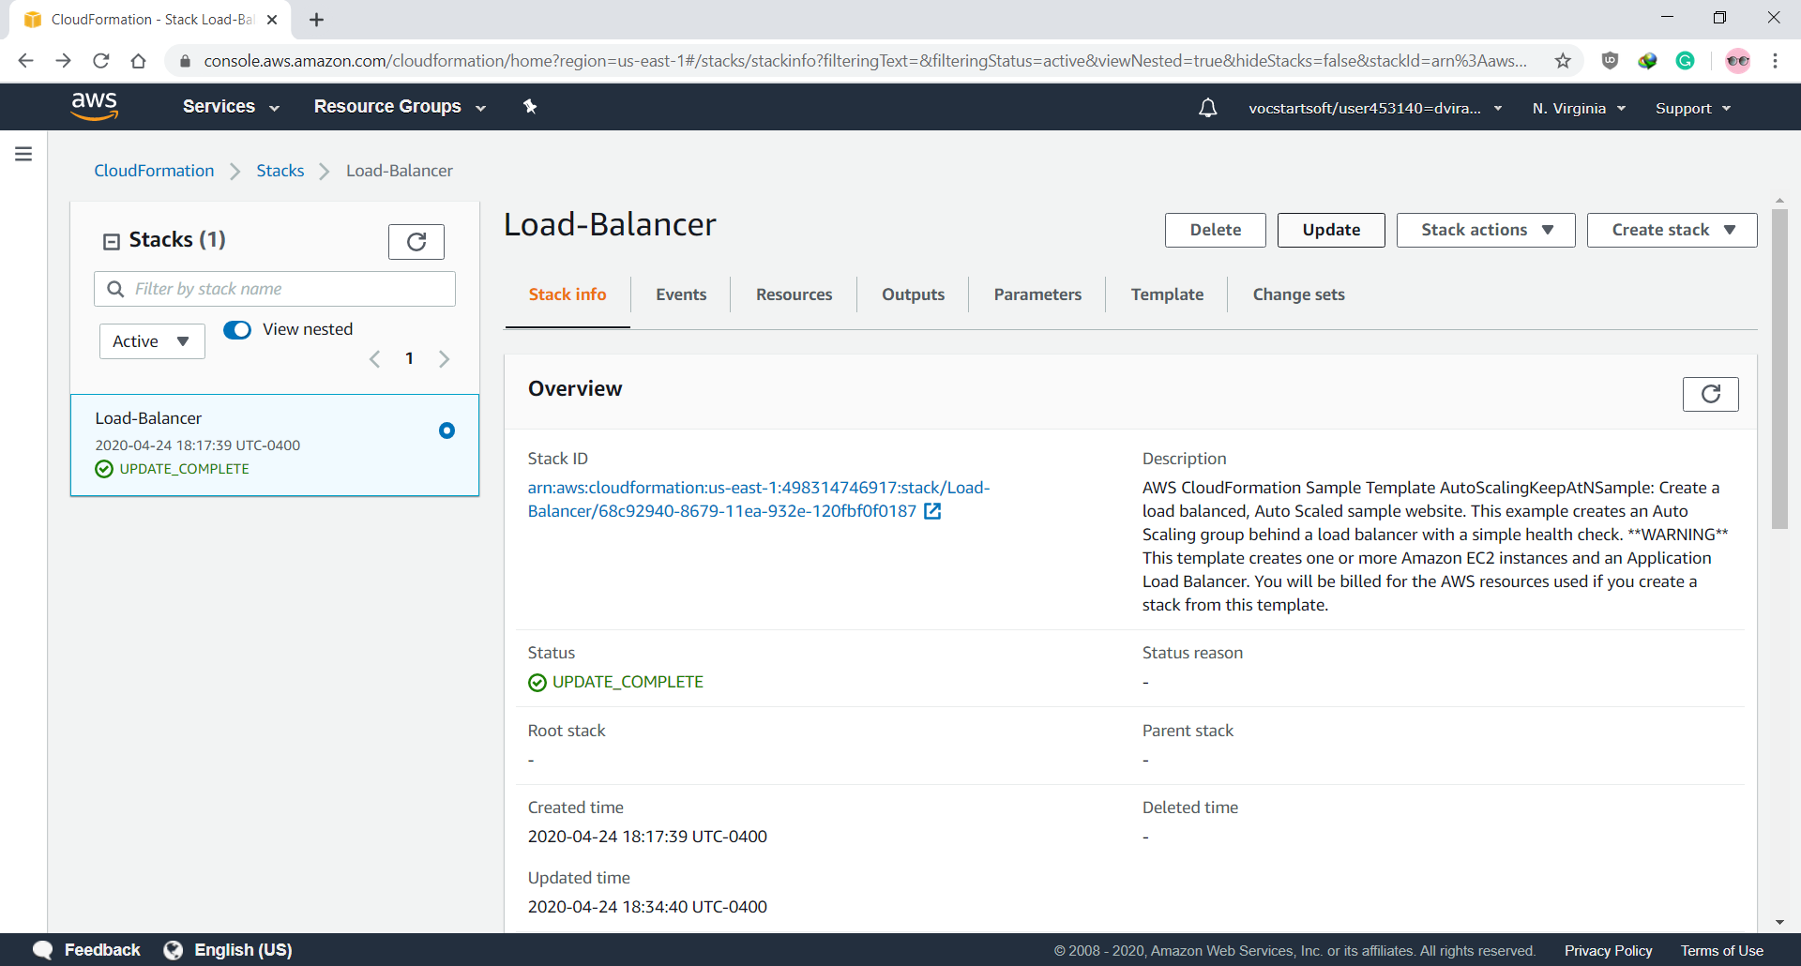

* While creating change set, we will provide the updated JSON template for Auto Scaling. Then, click next.

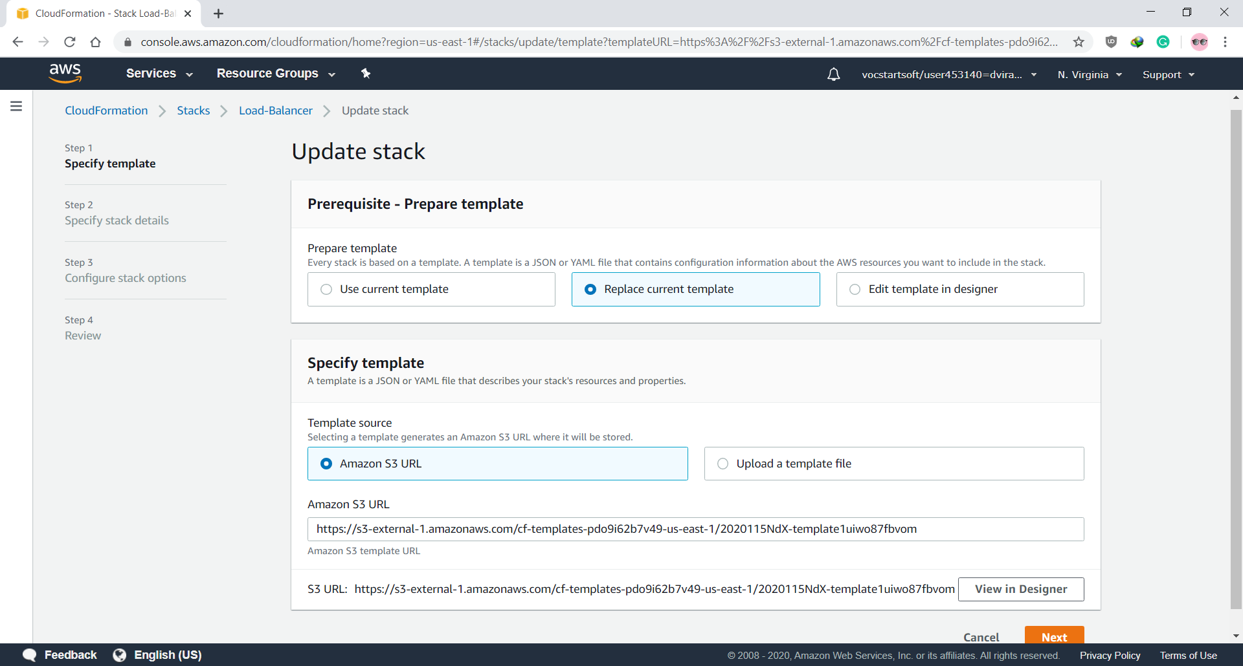

* After performing same steps, that we did while configuring template for stack creating

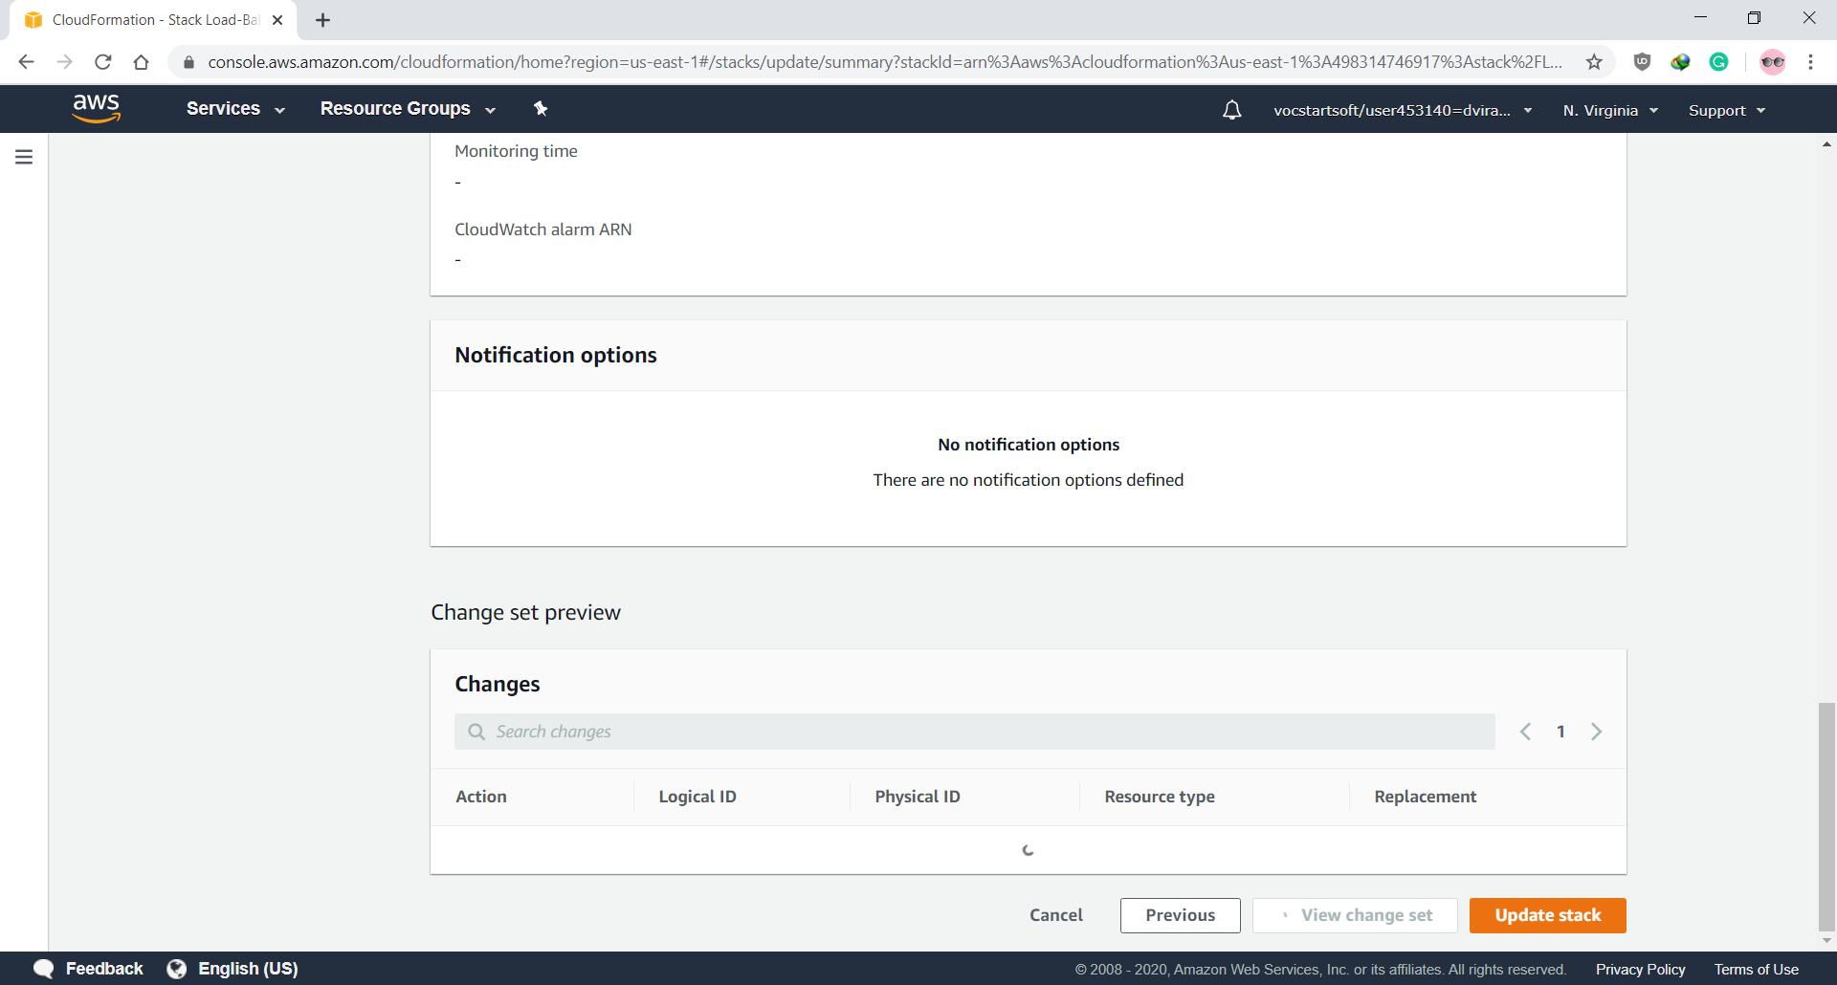

* After status change to “UPDATE_COMPLETE”. We can check the output of the Load Balancer.

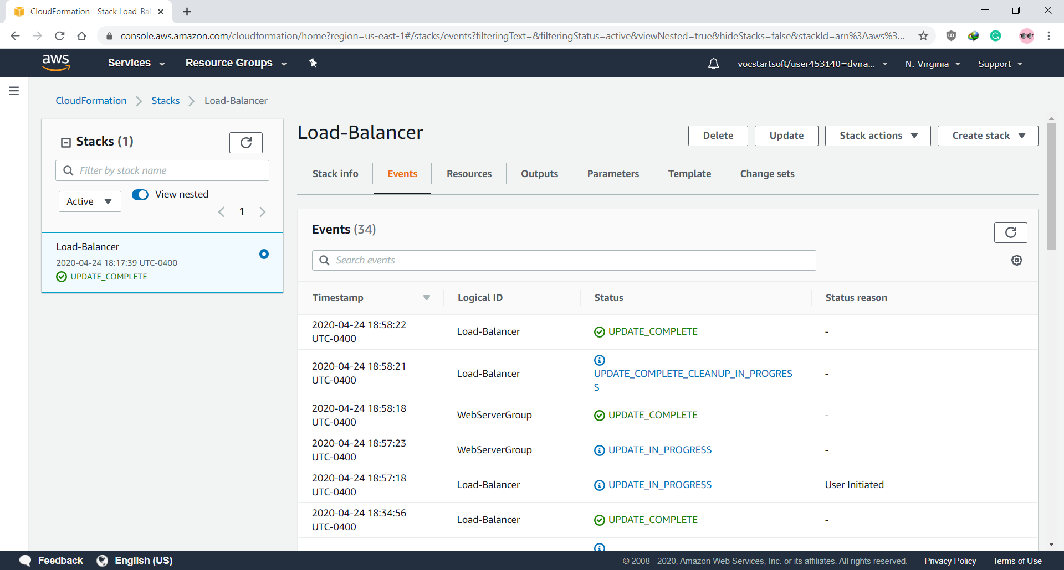

* Click on link from output tab to view Server page

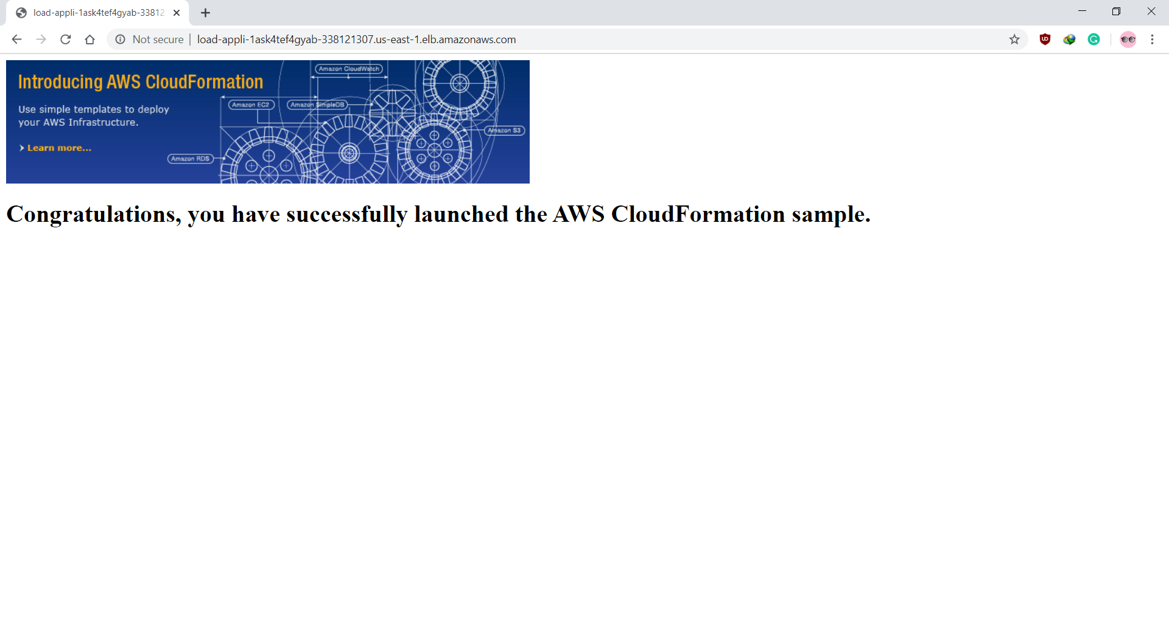

* After successful update of stack, we can check that the instances are running on the servers

Server 1

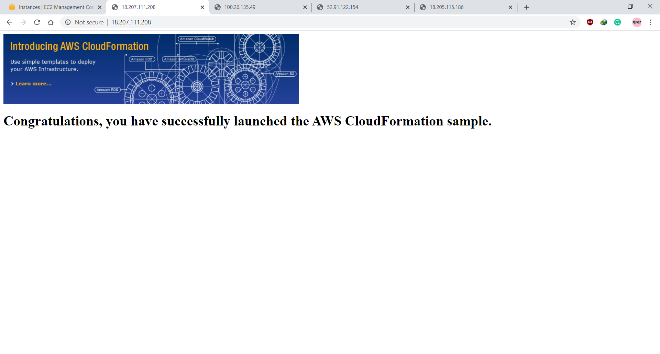

Server 2

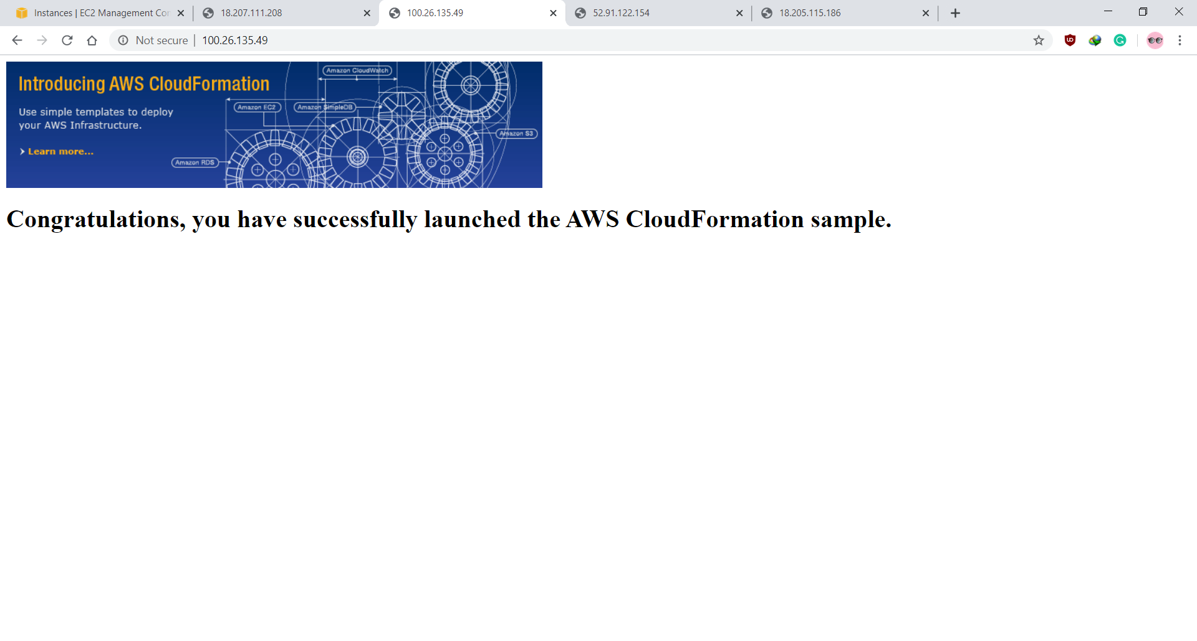

Server 3

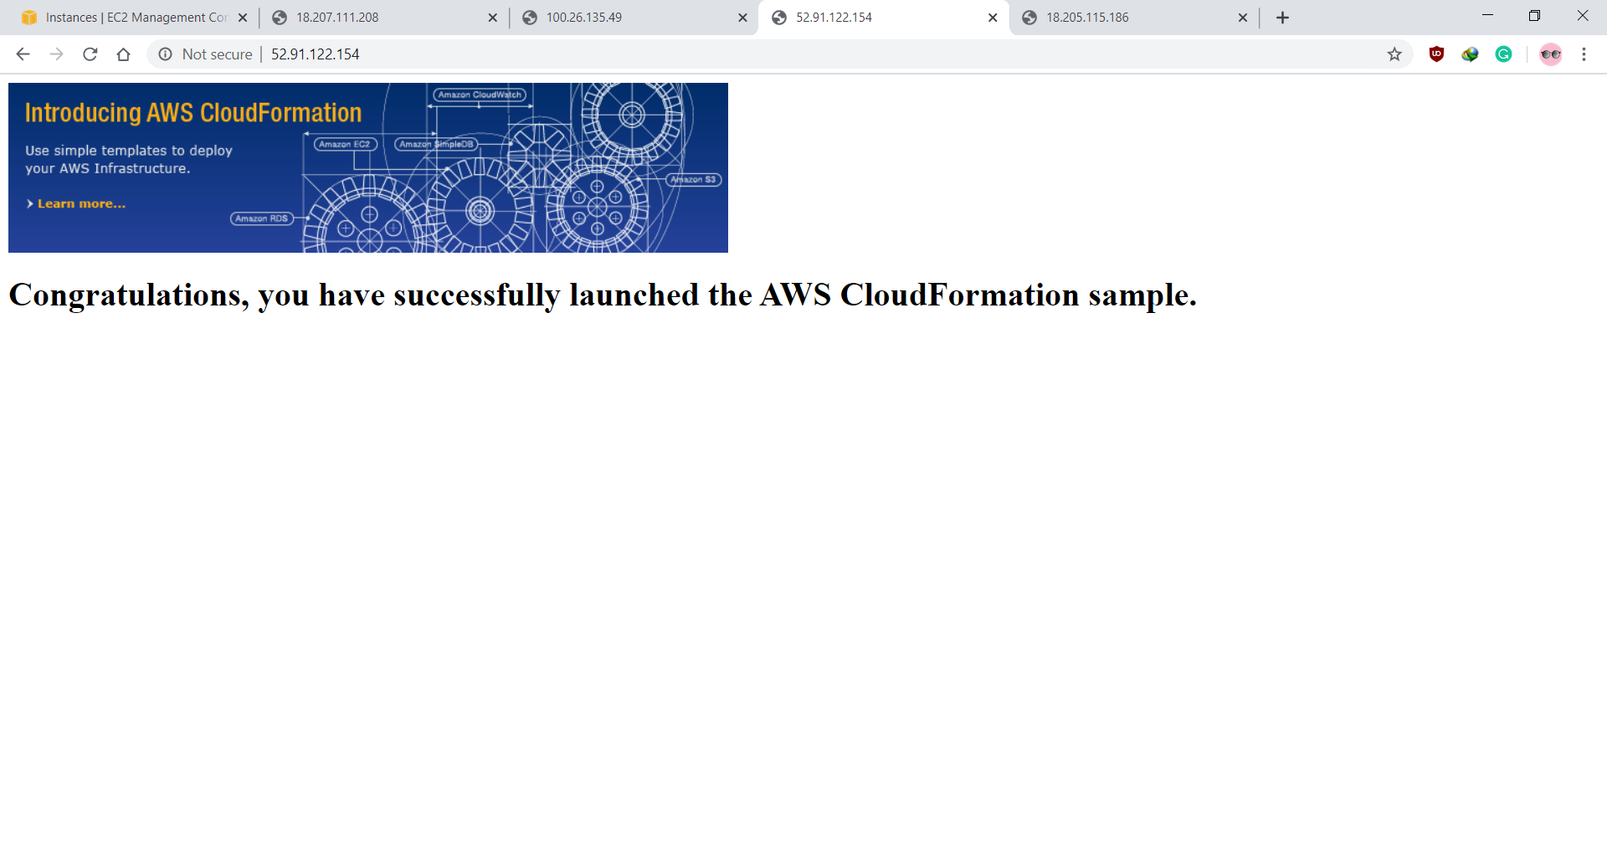

Server 4

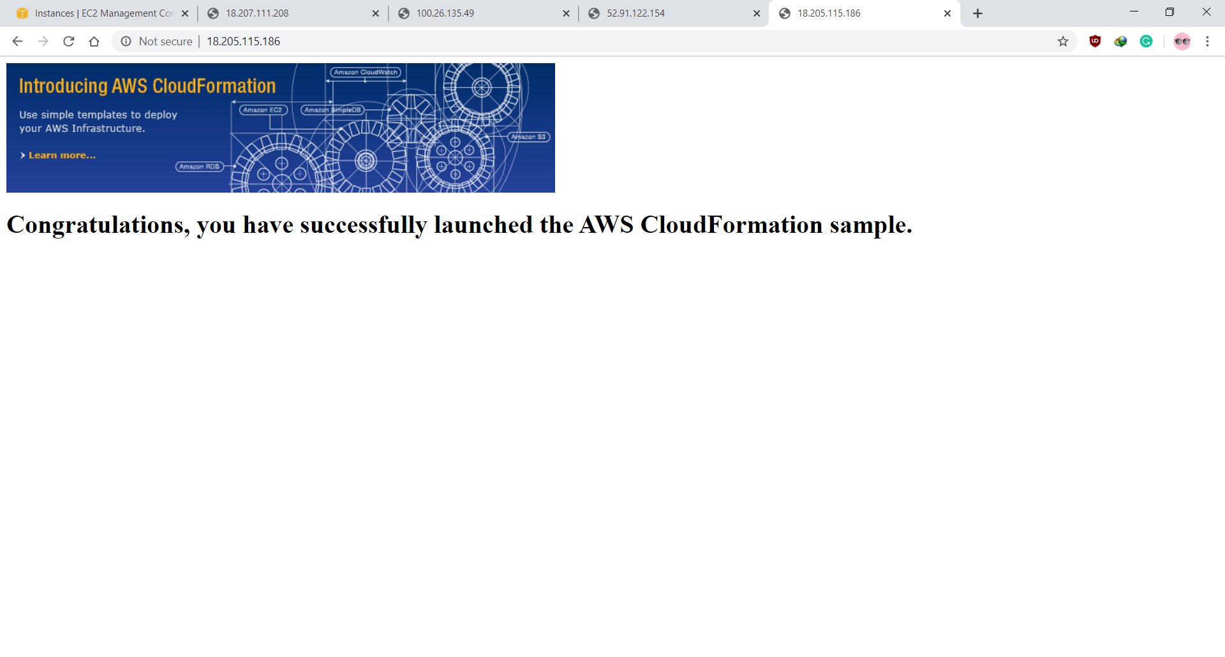

**Steps to change Servers index.html file on Amazon EC2 instance**

* Access the AWS Instance using command line by executing following command

$ ssh -i "ec2@dharmit.pem" ec2-user@ec2-3-227-19-192.compute-1.amazonaws.com

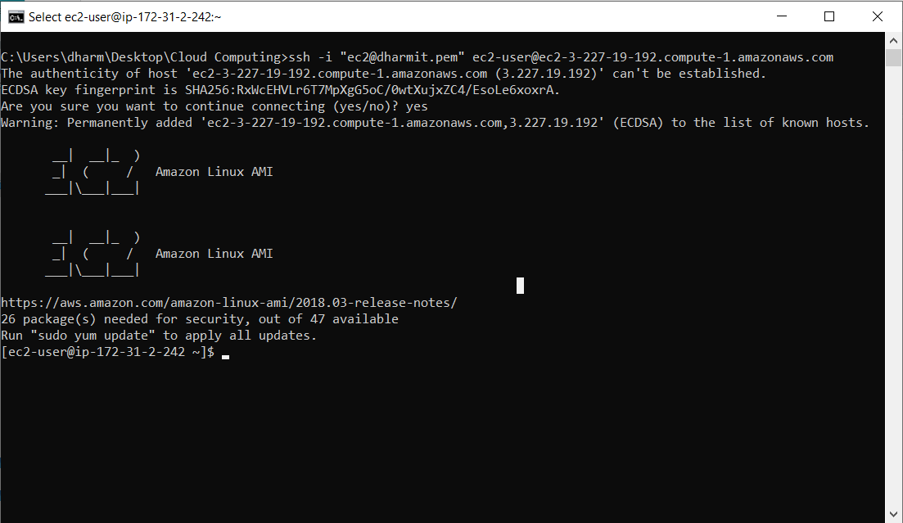

* Visit the index.html file location by executing following command

$ cd /var/www/html

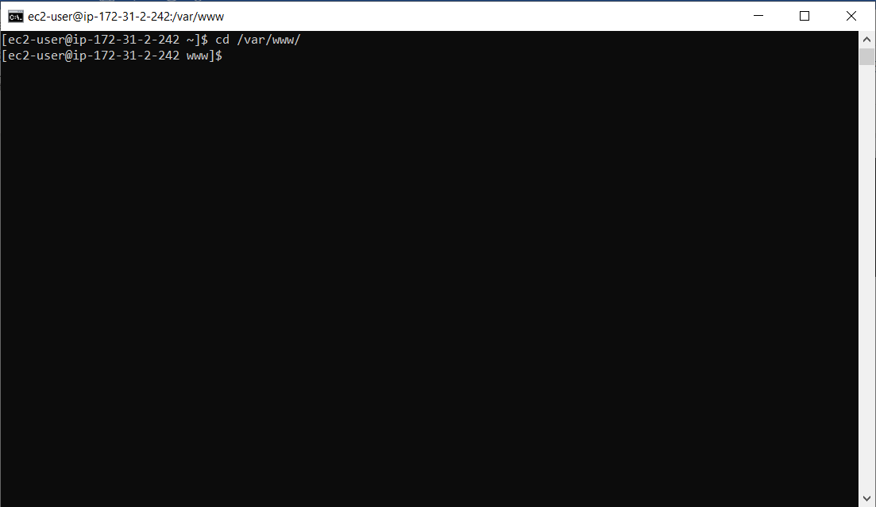

* Change the directory permission to allow ftp upload at the location

$ sudo chmod –R 777 html

$ cd html

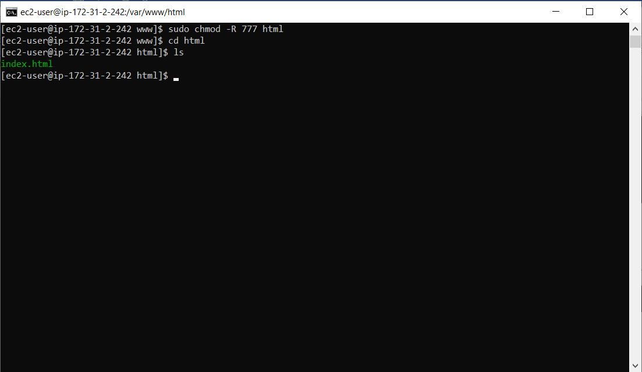

* Now access the AWS directory using WinSCP a famous FTP uploader

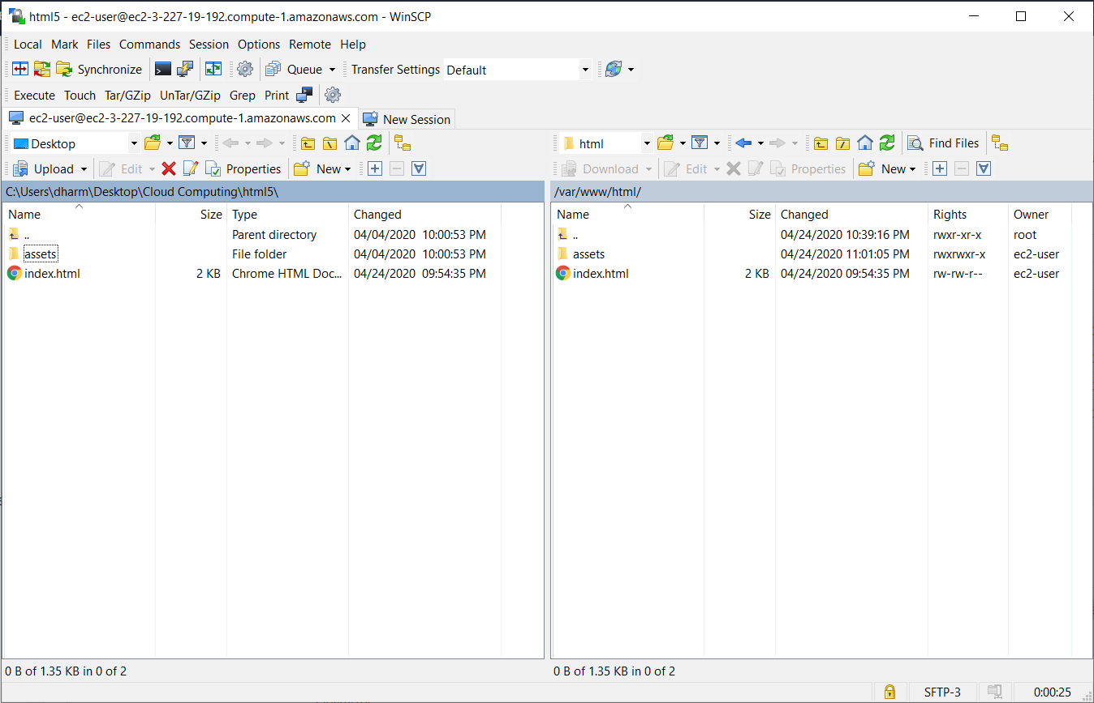

* Actual page on browser after editing index.html file over AWS EC2 for “Server 1” or Instance number 1.

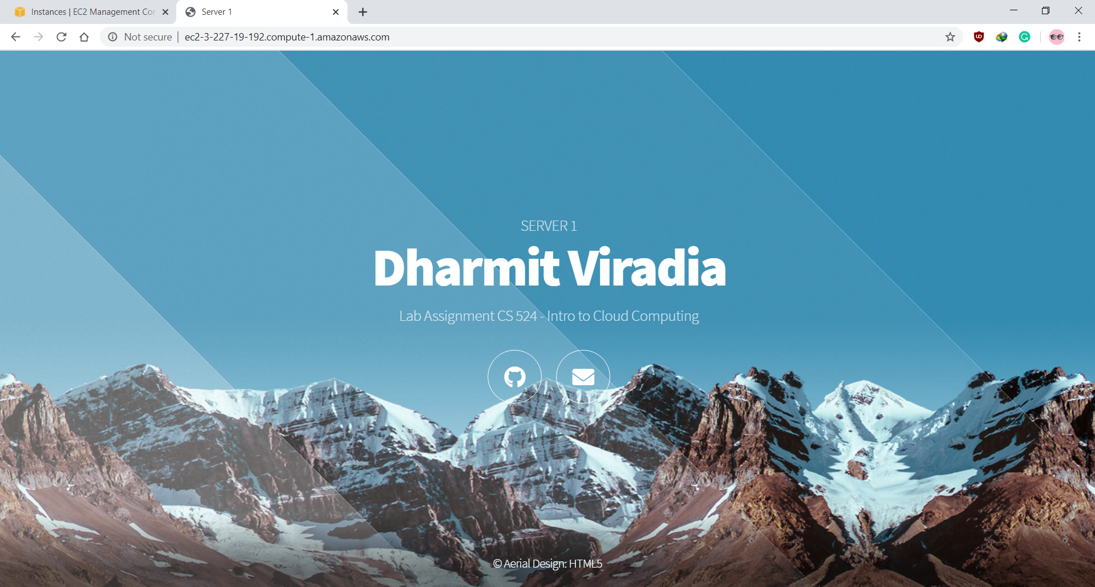

* Now, repeat the same steps to edit the index.html file on each instance you want. I have edited the index.html file for all my four instances i.e. Server 1, Server 2, Server 3, and Server 4.

Server 2

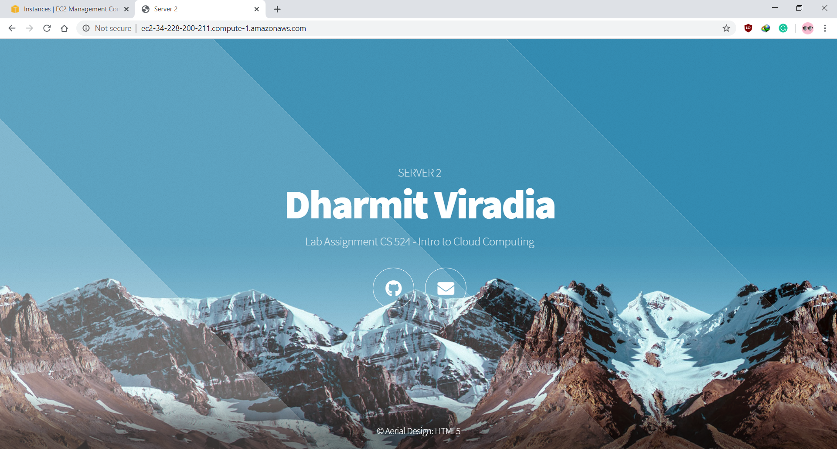

Server 3

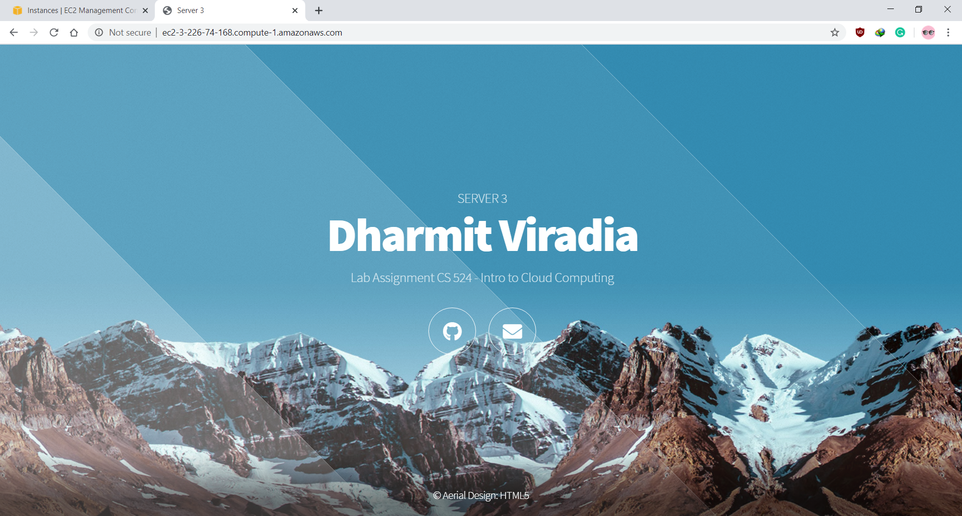

Server 4

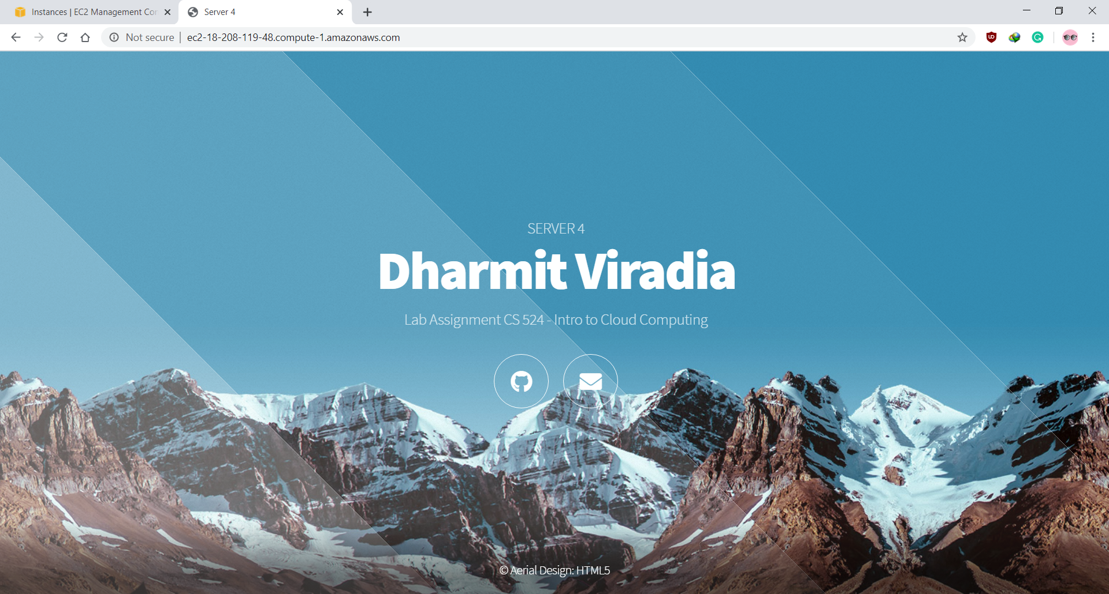

**Steps to check working of Load Balancer**

* Click on EC2 dashboard to find the Load Balancer and click on it

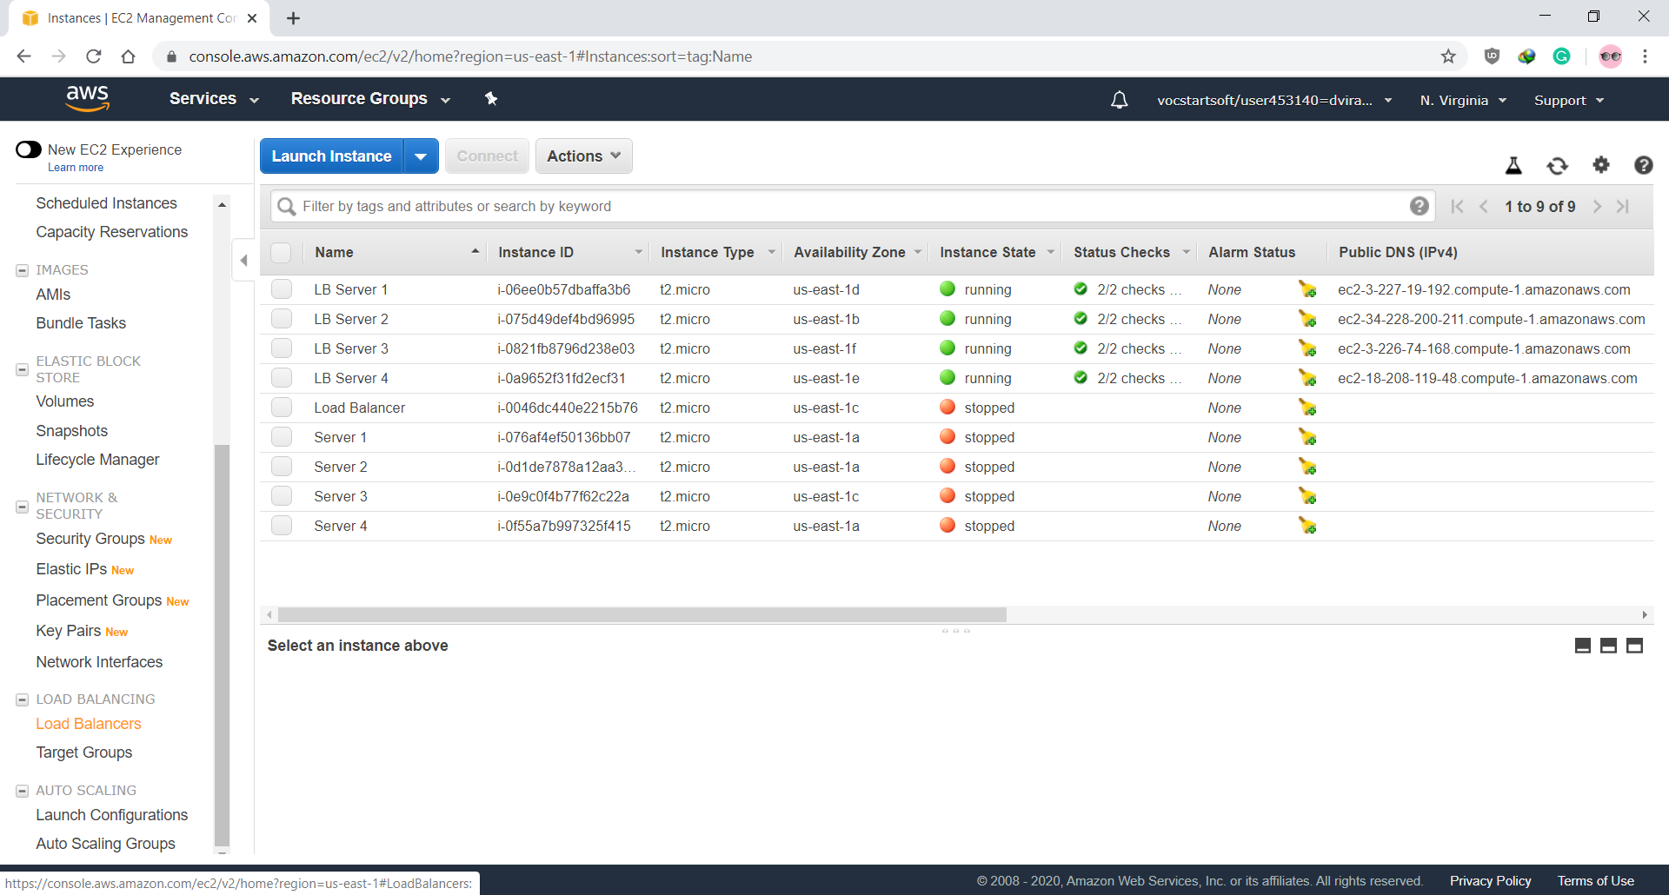

* After clicking Load Balancers, we will find a load balancer create while stack creation

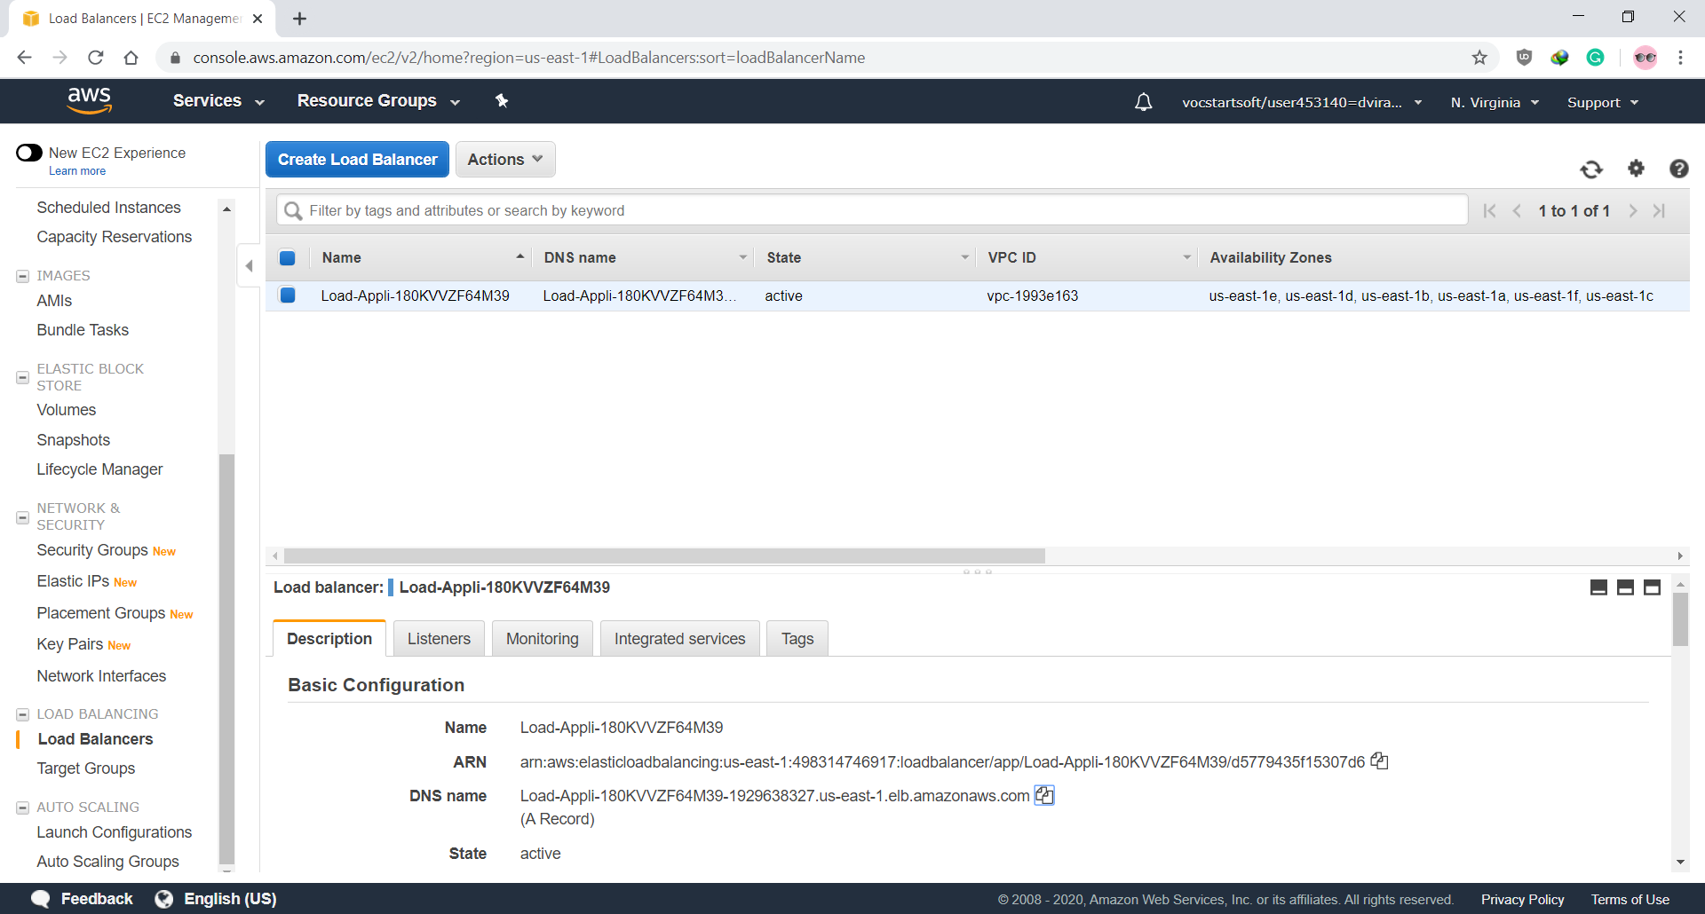

* Now visit the load balancer DNS Name and this load balancer automatically balances the load and redirect to any of the created servers by dividing the load at equal proportion

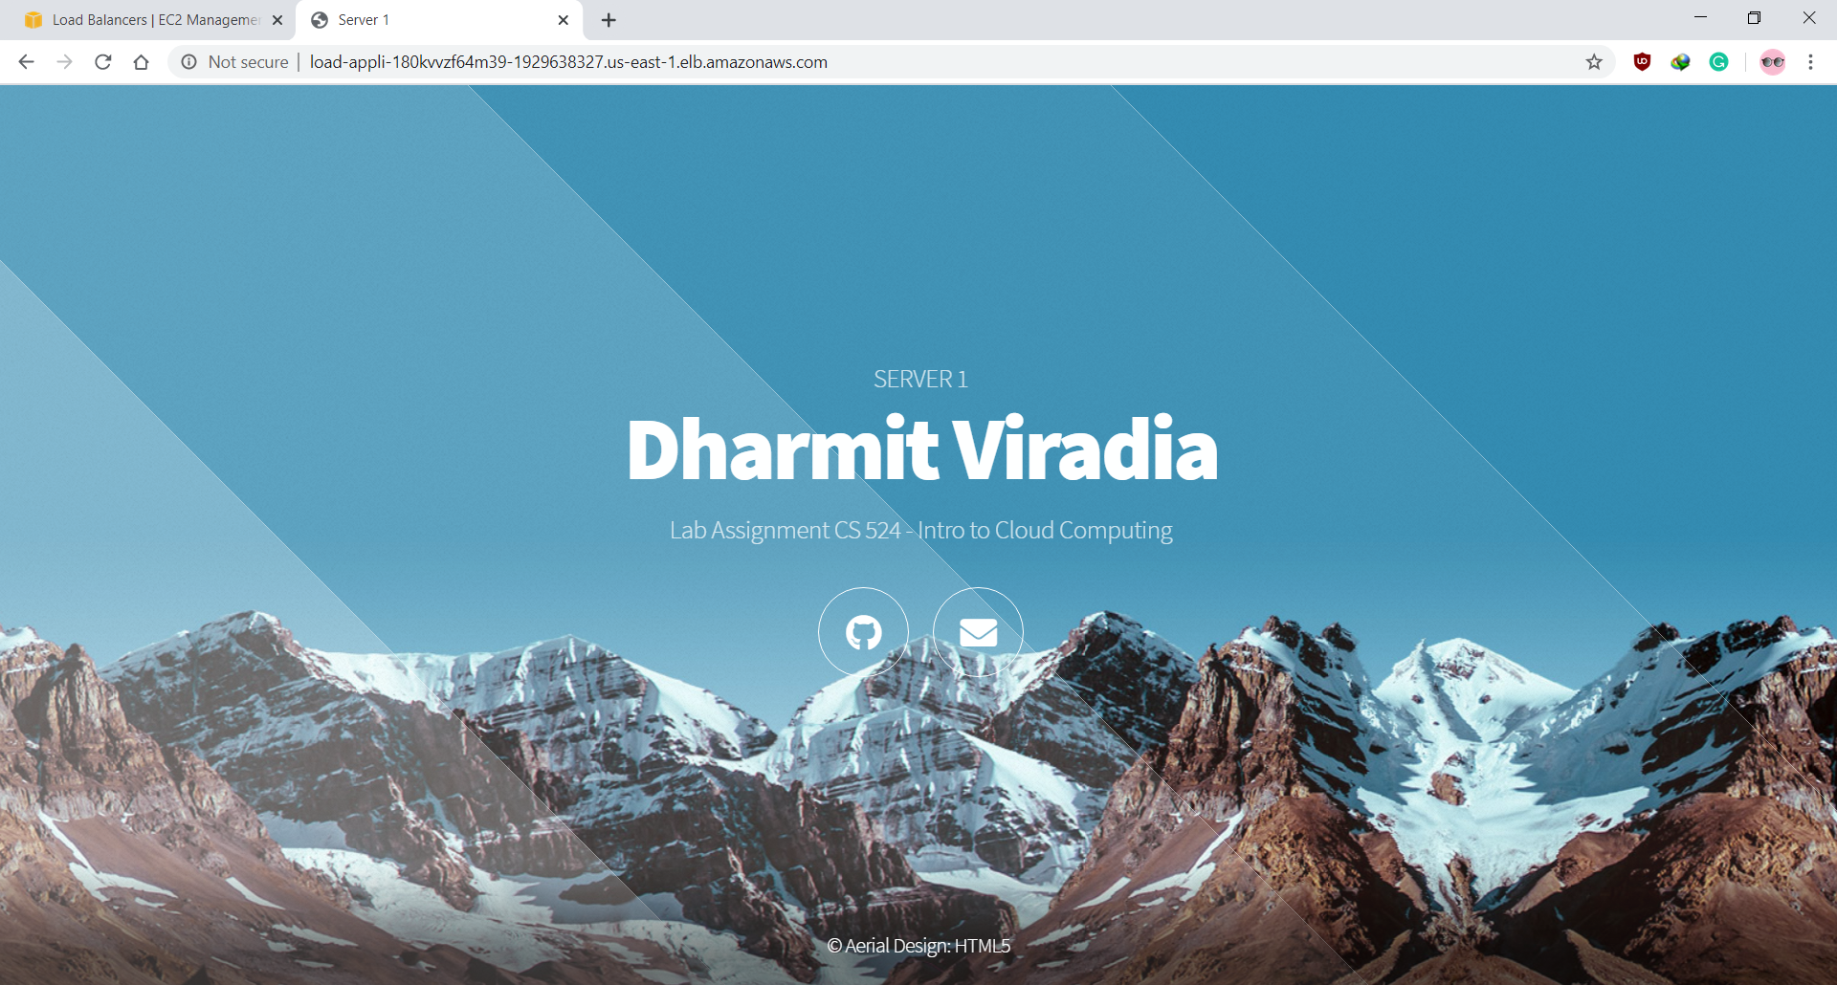

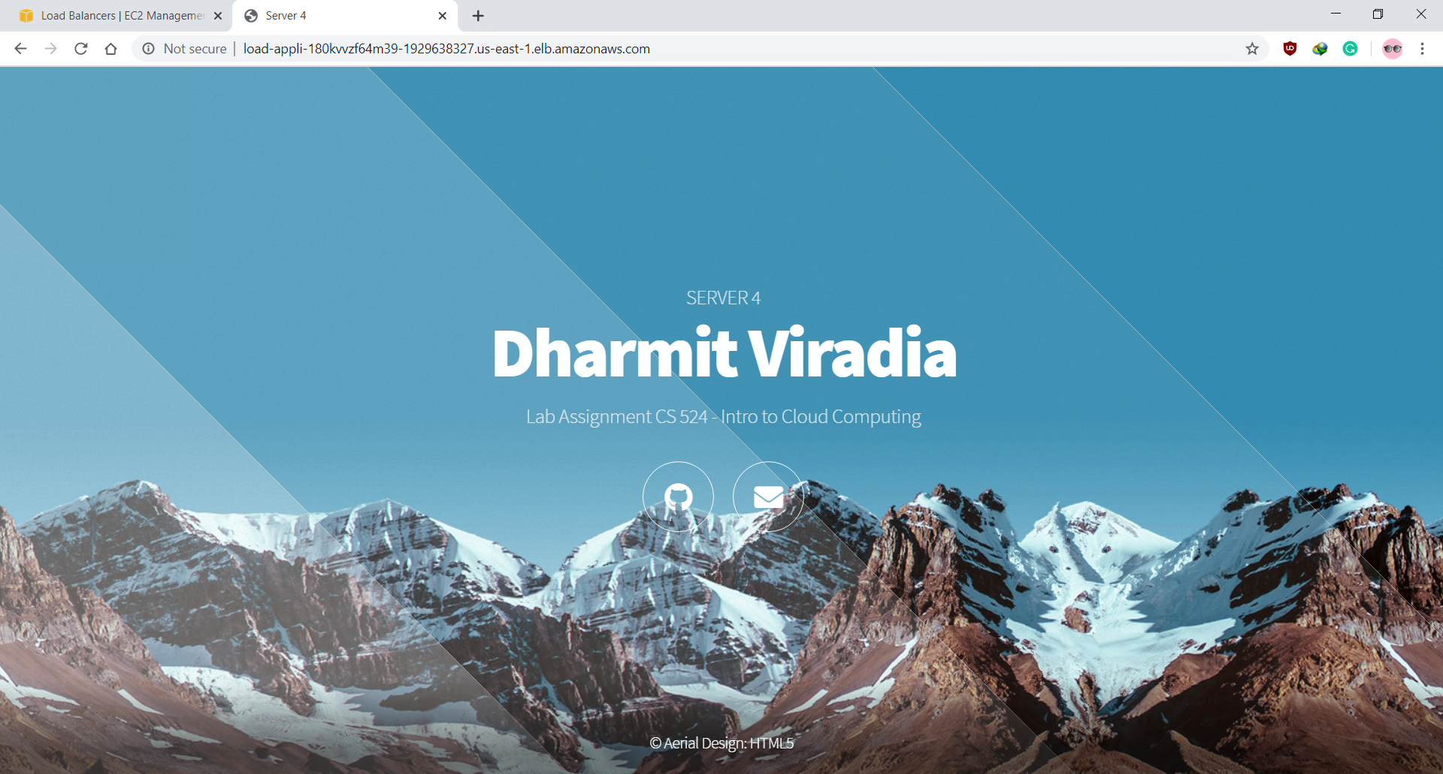

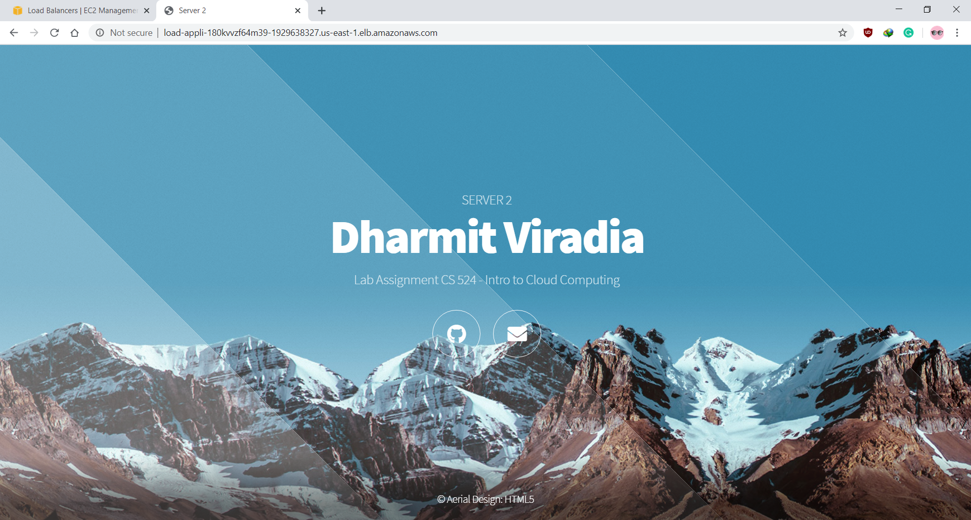

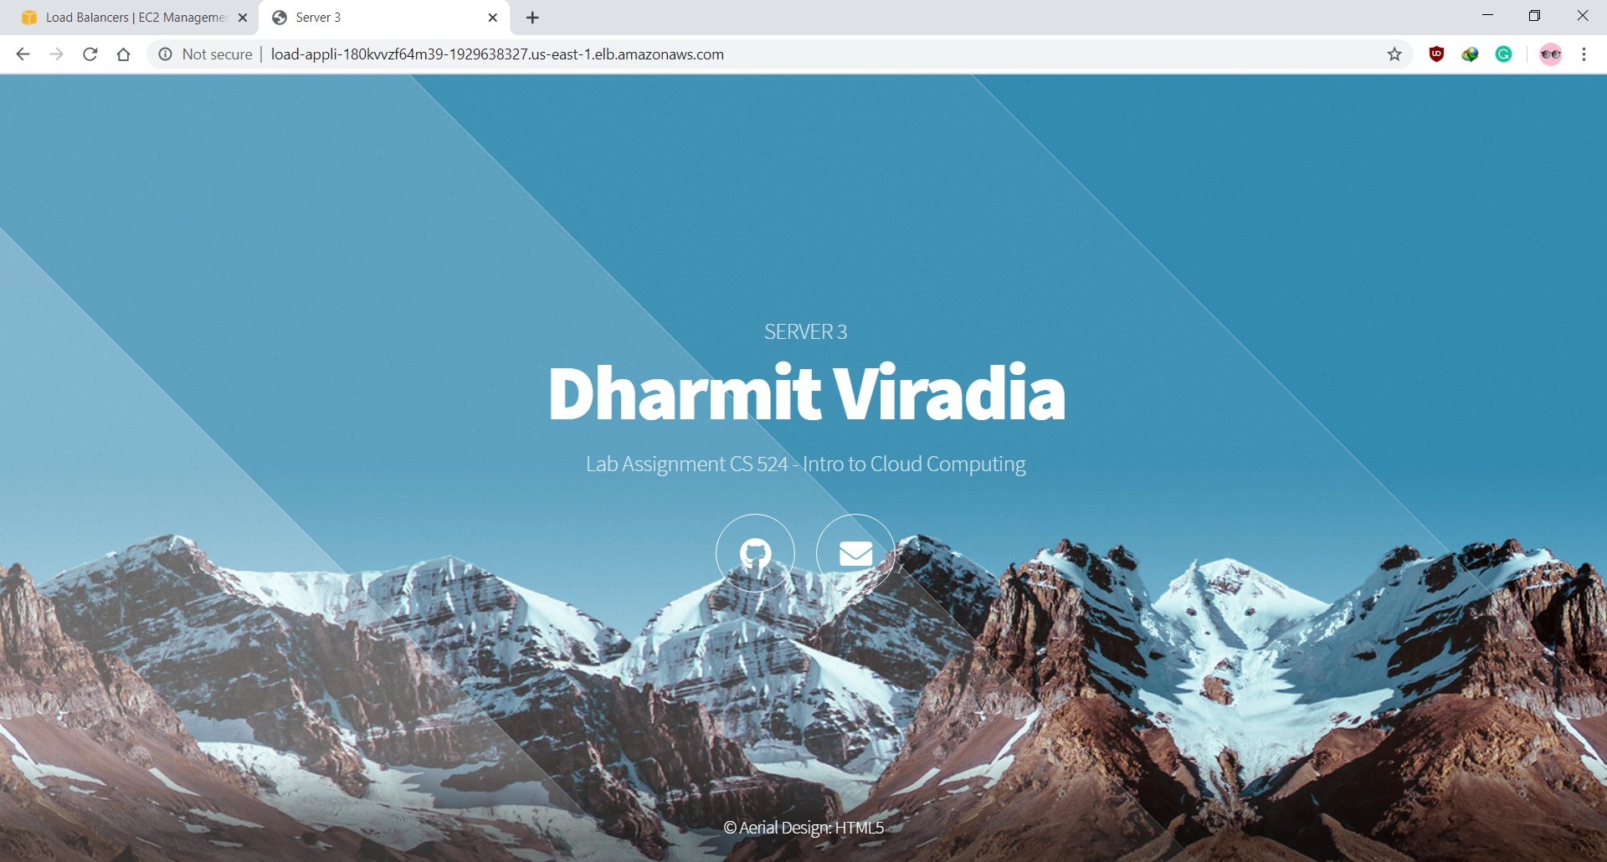

(In my case Server 1 ran First, then Server 4, then Server 2 and in Last Server 3)